Table of Contents
I. Chapter 110-12-1. Minimum Standards and Procedures for Local Comprehensive Planning 4
1. Introductions 4
2. History 5
Berrien County 5
City of Alapaha 5
City of Enigma 5
City of Nashville 5
City of Ray City 6
3. Community Involvement 6
4. Community Involvement 7
Stakeholders: 7
SGRC Staff: 7
Steering Committee: Error! Bookmark not defined.
5. Identification of Participation Techniques 8
6. Conduct Participation Program 8
1st Workshop (SWOT ANALYSIS) 9
2nd Workshop (SWOT ANALYSIS) 10
3rd Workshop Land Use Element/Character Area 11
7. Consideration of Regional Water Plan and Environmental Planning Criteria 12
Suwannee-Satilla Regional Water Plan 12
Suwannee-Satilla Regional Water Plan Goals: 14
Short-Term Water Quantity Management Practices (0-10 Years) Error! Bookmark not defined.
Longer Term (20 – 40 years) water quantity and quality management practices include: Error! Bookmark not defined.
Chapter 391-3-16, Rules for Environmental Planning Criteria Error! Bookmark not defined.
II. Plan Elements 16
Community Goals 16
Vision Statement 16
II. Needs and Opportunities 17
NATURAL RESOURCES AND CULTURAL RESOURCES 18
Needs 18
Opportunities 18
ECONOMIC DEVELOPMENT 18
Needs 18
Opportunities 18
HOUSING 19
Needs 19
Opportunities 19
LAND USE 19
Needs 19
Opportunities 19
TRANSPORTATION 20
Needs 20
Opportunities 20
COMMUNITY FACILITIES AND SERVICES 20
Needs 20
Opportunities 20
INTERGOVERNMENTAL COORDINATION 20
Needs 20
Opportunities 21
BROADBAND SERVICES 21
Needs 21
Opportunities 21
III. Analysis of Data and Information 21
Population Percentage Change 21
Population by Race 21
Median Age 22
Population by Age 22
Households & Families 22
Home Values 22
IV. Consideration of DCA Community Quality Objectives 23

I. Chapter 110-12-1. Minimum Standards and Procedures for Local Comprehensive Planning

Introductions
The 2020 Joint Berrien County and the Cities of Alapaha, Enigma, Nashville and Ray City Comprehensive Plan were prepared per the Rules of the Georgia Department of Community Affairs Chapter 110-12-1, Minimum Standards, and Procedures for Local Comprehensive Planning, effective October 1, 2018.
As required by the Local Comprehensive Planning Standards, the 2025 Joint Berrien County – Cities of Alapaha, Enigma, Nashville, and Ray City Comprehensive Plan Update consists of the following elements:
- Community Goals
- Needs and Opportunities
- Community Work Program
- Broadband Services
- Economic Development Element
(As a community included in the Georgia Job Tax Credit Tier 1 category),
a separate summarized economic development element is included in this Comprehensive Plan. By reference, it adopts the current regional Comprehensive Economic Development Strategy (CEDS). Also, any economic development goals, policies, needs, opportunities, and objectives about Berrien County and the Cities of Alapaha, Enigma, Nashville, and Ray City have been integrated directly into their parallel components in this Comprehensive Plan.)
- Land Use
(As a community with zoning or land development regulations subject to the Zoning Procedures Law)
- Transportation
- JLUS Comprehensive Land Use and Policies

History

Berrien County

Berrien County, located in the south-central portion of Georgia, was created on February 25, 1856. It is Georgia’s 116th county, created by an act of the Georgia General Assembly from parts of Coffee, Irwin, and Lowndes Counties. The county is named after the former U.S. Senator, U.S. Attorney General, and Georgia politician John Macpherson Berrien (1781-1856). The county contains four municipalities: Alapaha, Enigma, Nashville, and Ray City. Berrien County boarders Atkinson, Coffee, Cook, Irwin Lanier, Lowndes, and Tift Counties.

City of Alapaha
Alapaha developed from a trade settlement on the site of Seminole Village and depot, and operated in the town on the route of the Brunswick and Albany Railroad around 1874. The 1880s and 1890s brought an agricultural and industrial boom in forestry, timber and naval stores. Alapaha, incorporated in 1881. In 1897, a catastrophic fire destroyed many uninsured businesses in downtown Alapaha.
Alapaha was also known for the Atlantic Coast Line Railroad train wreck on March 26, 1911. The Dixie Flyer derailed on a high trestle across the Alapaha River, killing ten and injuring many wealthy Northern socialites who were traveling to the coast. Eight weeks before the Armistice ended World War 1, Alapaha lost four of the total of 25 men in the infamous Otranto troopship disaster, off the coast of Scotland.

City of Enigma
Enigma is a small town in southern Georgia, located in the northwest corner of Berrien County. Enigma was founded between 1876 and 1880, by John A. Ball and incorporated on August 21, 1906. It was originally a settlement, commonly referred to as “Gunn and Weston” until Ball decided he wanted a real name for the town. By definition, Enigma means a puzzle or mystery, and Ball said, “It was a puzzle what to name it anyway."

City of Nashville
Nashville, the county seat of Berrien County was incorporated as a town on December 20, 1892, and as a city in 1900. The town was originally founded in 1840 and named in like fashion to its Tennessee counterpart, Nashville, for the Revolutionary War hero General Francis Nash (1742-1777), fatally wounded in the Battle of Germantown. Nashville is the largest city within Berrien County with a total are of 4.7 square miles.

City of Ray City
Ray City was formally named Ray’s Mill and was located one mile east of the present town on Ray’s Mill Pond and was named for Thomas M. Ray retaining Ray’s Mill name for several years. The mill was operated by water from the pond to grind meal and hominy grits from the corn while being operated by Mr. Thomas Ray until his death. In 1909, Perry T. Knight, State Representative from Berrien County, introduced a bill to change the town’s name to Ray City. On August 16, 1909, Ray City became incorporated.
During the years of heavy rail traffic in Berrien County, the cutting of crossties was a very lucrative business. As the Great Depression had a devastating impact on Ray City, it suffered losses of many of its people and businesses. When Moody Air Force Base opened, it provided many needed jobs and helped to restore the City’s economic base. Many military families have chosen Ray City as their home following retirement.

Community Involvement
All of the required elements have been developed with extensive opportunity for involvement and input from stakeholders throughout the county and cities. The following steps were taken to ensure this plan reflects the full range of needs and opportunities from the many stakeholders and residents in the county:

- Stakeholders were identified. These included Mayors, City Council persons, County Administrators/Managers/Finance Directors, Code Enforcement Officers, Chamber of Commerce Director, Utilities Departments, Main Street Director, Assistant School Superintendent, Development Authority Director, and City Clerks.
- Participation techniques were identified. Techniques used included a kick-off public information meeting, printed public information in local newspapers, and information on the Southern Georgia Regional Commission’s website and local government websites. A steering committee was formed to oversee and participate in planned development, including representatives from the stakeholders mentioned above.
- A participation program was conducted. Identified stakeholders were invited and attended; yielding specific input in plan content. The steering committee reviewed the first draft of the plan.
- Community Involvement Activities documented. Included is a list of stakeholders, and overview of participation… (photos, sign-in sheets, agendas, minutes, published advertisements, emails, and SGRC website)

1st Public Hearing – “Kick Off”
The public hearing kick-off for the comprehensive planning process was held on March 26, 2024, at the Berrien County Commissioners Chambers at 201 North Davis St, Room 198, Nashville, Georgia. It was held to make any potential stakeholders and residents aware of the comprehensive plan update and that a review was now underway; to explain the purpose of the update, and to encourage residents and other stakeholders to actively participate in the plan update.
2nd Public Hearing - Transmittal of Document
The 2nd public hearing was held on December 3, 2019, at the Berrien County Commissioners Chamber at 201 North Davis St., Room 198, Nashville, Georgia. The purpose of this meeting was to receive approval to submit the document for review by the Georgia Department of Community Affairs.

Community Involvement
A comprehensive list of potential stakeholders was put together with input from the Chamber of Commerce, Development Authority, elected officials, and residents. A special acknowledgment is deserved for the members of the Stakeholders, Steering Committee, and SGRC Staff who dedicated their time and hard work for this project:

Stakeholders:
- Brenda Exum, Ray City Mayor
- Denise Ray, Ray City
- Lisa Smart, Chamber/Berrien County Economic Development
- Teresa Willis, Nashville
- Amy Garner, Nashville City Council
- Sandy Mizell, Berrien County EMA Director
- Ronnie Gaskins, Berrien County Chairman
- Gerald Sumner, Berrien County EMS
- Vickie Harsey, Alapaha City Council
- Bud Hutchinson, Engima City Council
- April Martin, Berrien EMA/911

SGRC Staff:
- James Horton, Planning Director
- Marcus McConico, Planner I
- Alexandra Arzayus, Planner II
- Mykaela Brown, Planner I

Identification of Participation Techniques
- The following participation techniques were utilized during the update process:
- Public Hearings
- Workshops
- Extensive e-mail correspondence with stakeholders
- Special web page on SGRC website as well as County and Cities websites
- Dissemination of information in the newspaper

Conduct Participation Program
A foundational principle utilized by the Southern Georgia Regional Commission in all of its planning projects is public and stakeholder participation from, and coordination with, multiple and diverse interest groups. Outreach to the public, local governments, and other stakeholders and interested parties was accomplished by e-mail correspondence, direct communication, the project website, and updates provided at workshops and other group meetings. Opportunity for public comment was presented at public hearings and city and county commission meetings. The Steering Committee reviewed the plan ensuring the broadest buy-in and diversity of input into the comprehensive plan update.

In addition to the two required public hearings, SGRC held a series of three workshops to discuss several elements of the plan. The first workshop was used to review the existing goals, issues, and opportunities; in the form of a SWOT (Strengths, Weaknesses, Opportunities, and Threats) analysis, participants updated the list of goals, issues, and opportunities to meet current needs. Copies of the sign-in sheets are provided in the appendix along with public hearing notices.

The policies were reviewed to reflect the revised issues and opportunities. The Report of Accomplishments and Community Work Program was discussed and developed in individual meetings with each community. Emphasis was put on achievable, realistic projects for the next five years. A section for long-term projects the communities plan to undertake has been added to the Community Work Program.

The third workshop was utilized to update the Economic Development Element and the Land Use Element and Maps as desired by the local governments.

In addition to the two required public hearings, SGRC held a series of three workshops to discuss several elements of the plan.

1st Workshop
(SWOT ANALYSIS)
The first workshop, held on September 5, 2023, was used to review the existing goals, needs, and opportunities; in the form of a SWOT (Strengths, Weaknesses, Opportunities, and Threats) analysis, participants updated the list of goals, issues, and opportunities to meet current needs. Copies of the sign-in sheets are provided in the appendix along with public hearing notices.

PHOTO OF WORKSHOP

2nd Workshop
(SWOT ANALYSIS)
The Policies and Report of Accomplishments were developed in the second workshop, held on October 3, 2024, along with the draft of the updated Community Work Program. The Community Work Program was designed by the participants to include specific action items and projects, feasible for the County and the individual communities to implement should funding become available. We also had meetings with each jurisdiction to discuss the Updated 5-Year Community Work Program.

PHOTO OF WORKSHOP

PHOTO OF WORKSHOP

3rd Workshop
Land Use Element/Character Area

The third workshop, held on June 6, 2019, was utilized to update the Economic Development Element and the Land Use Element and Maps as desired by the local governments.

PHOTO OF WORKSHOP

PHOTO OF WORKSHOP

Consideration of Regional Water Plan and Environmental Planning Criteria
During the preparation of the Comprehensive Plan, the local governments must review both the Regional Water Plan covering its area and the GDNR Rules for Environmental Planning Criteria, as laid out in Chapter 391-3-16, to determine whether any local implementation practices or development regulations need to be adapted to be consistent with both.

Suwannee-Satilla Regional Water Plan

Berrien County is within the area of the Suwannee-Satilla Regional Water Plan, which was adopted in June 2023. The Suwannee-Satilla Council is one of 11 planning regions charged with developing Regional Water Plans and encompasses 18 counties in the southeastern portion of Georgia
(shown in Figure ES-1). An overview of the updated findings and recommendations for the Suwannee- Satilla Region are provided in this Executive Summary. The Suwannee- Satilla Council’s Regional Water Plan is available on the Council’s website.

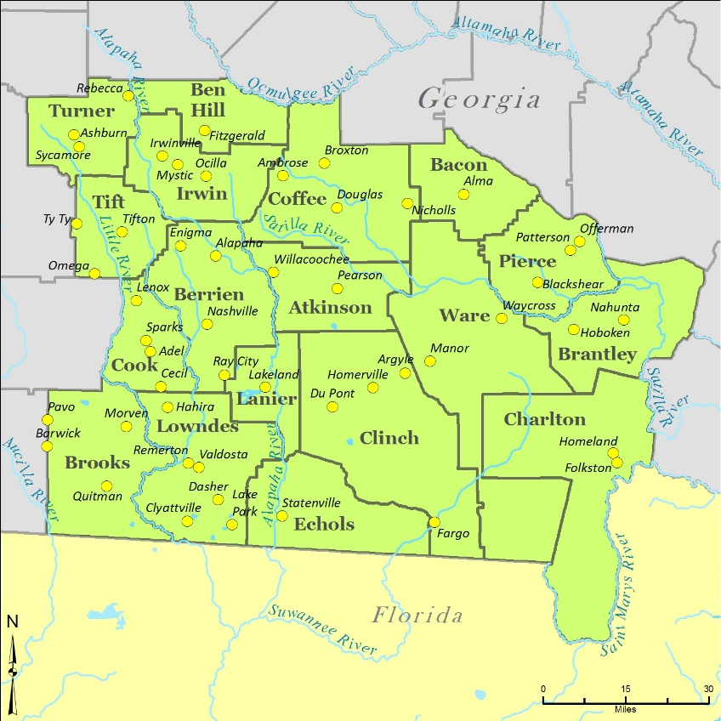
Source: CDM Suwannee-Satilla Regional Water Plan Figure ES-1

The Suwannee-Satilla Council has identified 13 goals for the region. It is important to note that the goals are summarized below, not presented in order of priority, but instead were assigned a number to identify specific goals addressed as part of the water management practice selection process.

“The Vision of the Suwannee- Satilla Regional Council is to manage water resources in a sustainable manner under Georgia’s regulated riparian and regulated reasonable use laws to support the state’s and region’s economy, to protect public health and natural resources, and to enhance the quality of life for all citizens; while preserving the private property rights of Georgia’s landowners, and in consideration of the need to enhance resource augmentation and efficiency opportunities.”

Suwannee-Satilla Regional Water Plan Goals:

1. Manage and develop water resources to sustainably and reliably meet domestic, commercial, industrial water needs, and agricultural water needs, including all agricultural sectors (this includes the agroforestry economy of the region).

2. Manage groundwater and surface water to encourage sustainable economic and population growth in the region.

3. Manage the region’s and state’s water resources in a manner that preserves and protects private property rights.

4. Ensure an adequate water supply of suitable quality to meet current and future human needs, while protecting environmental resources.

5. Identify opportunities to optimize existing and future supplies, and water and wastewater infrastructure.

6. Promote efficient use and management of surface and groundwater resources to allow for sufficient supplies for current and future generations.

7. Protect and manage surface and groundwater recharge areas to ensure sufficient long-term water supplies for the region.

8. Protect, maintain, and where appropriate and practicable, identify opportunities to enhance water quality, and river base flows.

9. Protect and maintain regional water-dependent recreational opportunities.

10. Identify opportunities to manage stormwater to improve water quantity and quality.

11. Identify and implement cost-effective water management strategies.

12. Seek to provide economically affordable power and water resource service to all citizens of the region.

13. Identify and implement actions to better measure and share water use data and information.

Addressing Water Needs and Regional Goals
This Section presents the Suwannee-Satilla Council’s water management practices selected to address resource shortfalls or challenges identified and described in Section 5, and/or meet the Council’s Vision and Goals described in Section 1.

Identifying Water Management Practices
The comparison of Resource Assessments and forecasted needs presented in Section 5 identifies the Region’s likely resource shortfalls or challenges and demonstrates the need for region and resource specific water management practices. In the cases where shortfalls or challenges appear to be unlikely based on the comparison of the Region’s Resource Assessments and forecasted needs, the management practices described in this section have been selected to also meet those needs specified by the
Council (e.g., facility/infrastructure needs and practices, programmatic practices, etc.) that are aligned with the Region’s Vision and Goals. In selecting the actions needed (i.e., water management practices), the Council considered practices identified in existing plans, the Region’s Vision and Goals, and coordinated with local governments and water providers as well as neighboring Councils who share these water resources.

Review of Existing Plans and Practices
The Council conducted a comprehensive review of existing local and regional water management plans and relevant related documents to frame the selection of management practices. The types of plans/studies that were reviewed to support identification and selection of management practices for the Suwannee-Satilla Region consisted of the following:
• Comprehensive Work Plans (local and regional scale)
• Regional infrastructure and permitting plans
• EPD databases (permitted withdrawals, planned projects, and proposed reservoirs)
• State-wide guidance documents (conservation, cost, and water planning)
• Best Management Practices (forestry, agriculture, and stormwater management)
• Water quality studies including Watershed Protection Plans (basin, watershed, and local scale)
• TMDL evaluations
When possible, successful management practices already planned for and/or in use in the Suwannee-Satilla Region formed the basis for the water management practices selected by the Council.

II. Plan Elements

Community Goals

Vision Statement
Berrien County and the Cities of Alapaha, Enigma, Nashville, and Ray City envision working together to provide all citizens and visitors of Berrien County with a high quality of life. The high quality of life shall include a strong economy, safe communities, educational opportunities, a clean environment, and excellent public services for all.
Goal 1: Natural and Cultural Resources. Encourage the protection and conservation of the vibrant historical heritage in Berrien County, including the Cities of Alapaha, Enigma, Nashville, and Ray City.

Goal 2: Economic Development. Create and maintain a long-term sustainable and diverse economic base.

Goal 3: Housing. Ensure that residents within Berrien County have access to quality and affordable housing.

Goal 4: Land Use. Establish and maintain conservation and protection of natural areas, where those areas would be endangered by development. These areas include, but are not limited to, floodplains, wetlands, groundwater recharge areas, protected river corridors, and forested hardwood areas, and areas where Georgia and Federally Endangered species and habitat exist.

Goal 5: Transportation. To promote transportation facilities, which protect our community resources, promote efficient use of infrastructure, and support quality economic development.

Goal 6: Community Facilities & Services. Develop and maintain public services and facilities to accommodate existing development and to encourage future sustainable growth in areas where community facilities and services are provided at adequate capacities.

Goal 7: Intergovernmental Coordination. Enhance and maintain communication between each jurisdiction and surrounding counties to efficiently and effectively serve the residents of Berrien County.

Goal 8: Broadband Services. Ensure broadband services are accessible throughout the communities and are consistent, reliable, and equitable.

II. Needs and Opportunities

The Needs and Opportunities, as shown in this Section, were developed through discussions with stakeholders and residents, and analysis of statistical data and information. The stakeholders reviewed and revised as applicable, the issues and opportunities identified in the 2025 Partial Update for Berrien County and the Cities of Alapaha, Enigma, Nashville, and Ray City. Each of the following needs and opportunities are addressed in the Community Work Program.

NATURAL RESOURCES AND CULTURAL RESOURCES

Needs
- Expand Cultural Resources: Increase the availability of cultural and historical resources across the county and cities to enhance community engagement.
- Grant Research and Application: Identify and apply for grants that align with local funding needs to support community initiatives.
- Increase Hotel Capacity: Encourage the development of more hotel accommodations throughout the county and cities to support tourism and local events.
- Promote Local Museums: Improve marketing efforts for the Courthouse Museum and other small museums in Alapaha to boost visibility and attract more visitors.

Opportunities
- Promote Public Fishing Areas: Highlight the Paradise Public Fishing Area and other local fishing spots, including the Alapaha River, to attract fishing enthusiasts and outdoor tourism.
- Enhance Historic Tourism: Encourage economic development and tourism by promoting the county’s historic buildings, including the County Courthouse and other significant sites throughout the area.
- Develop Cultural Resources: Create additional cultural attractions and programs to entice tourists and strengthen the county’s appeal as a cultural destination.
- Explore Native American Heritage: Research the county's Native American history and explore opportunities to develop tourism attractions that celebrate and educate visitors on this heritage.

ECONOMIC DEVELOPMENT

Needs
- Lack of enough work force to entice new industry
- Need to increase affordable housing throughout the cities and county
- Too many commercial buildings are vacant
- Need for E-vehicle Charging stations

Opportunities
- There is room for future economic growth throughout the county
- Lower taxes compared to surrounding counties
- Berrien County schools are above average and is rated higher that surrounding public school systems.
- Explorer the possibilities of expansion of current industries throughout the county
- Explore the feasibility of creating a business park
- Encourage economic develop by considering the possibility expanding the Berrien County Recreation Department to bring in athletic tournaments
- Proximity to state highways 82 and 129

HOUSING

Needs
- Need for more affordable housing
- Need to redevelop older housing stock
- Available land for purchase to develop for housing

Opportunities
- Berrien county has land and room to increase the housing stock
- Revitalize and bring up to code older homes, in Nashville, Ray City, Enigma, Alapaha, and in the county.
- Lower cost of living/housing than surrounding counties
- Utilize Community Development Block Grant to rehab existing housing and aid in the construction of new housing.
- Identify land throughout the county and cities to be developed for future housing.

LAND USE

Needs
- Land use codes need to be update for the county
- Enigma needs to adopt a zoning ordinance.
- Alapaha needs to adopt a zoning ordinance.
- Develop appropriate land development regulations for the County and the Cities.

Opportunities
- Identify areas for future development and develop infrastructure for desirable development.
- Promote conservation areas throughout Berrien County

TRANSPORTATION

Needs
- The County still has dirt roads, repave roads throughout the cities.
- Need for more sidewalks all the cities in Berrien County.
- Cities of Alapaha, Enigma, and Ray City need Gateway entrances into cities.
- There is a need for roads in the County and Cities to be repaired or repaved and improve drainage issues.
- Add pedestrian Safety measures throughout the county and cities

Opportunities
- Create a plan for future expansion of airport
- Strategize about future expansion of railway
- Creating safer roadways for all residents and visitors to Berrien County and the cities of Alapaha, Enigma, Nashville, and Ray City
- Use TSPLOST discretionary funds to repair sidewalks and potholes

COMMUNITY FACILITIES AND SERVICES

Needs
- The county could utilize a large multi-purpose facility
- EMS station for the South ends of the county
- Saddle Club Arena is not covered
- Electric Charging station for residents or visitors that on E-vehicles

Opportunities
- Recreation Department hosting regional, district, state tournaments
- Saddle Club hosting events/competitions
- Adding Electric Charging stations in the county and cities
- Indoor Multi-purpose sports facility
- Work with Red Cross to identify possible emergency shelter location

INTERGOVERNMENTAL COORDINATION

Needs
- The need for more people within the local governments
- There needs to be better communication between the county and each of the cities
- Community needs to have more project specific opportunities are needed to assure success of the county and cities
- All county and city governments need cooperation in the development of the Service Delivery Strategy

Opportunities
- The Cities and County should have shared goals
- The County and Cities together need to continue to improve the Service Delivery Strategy.

BROADBAND SERVICES

Needs
- The county only has one broadband provider

Opportunities
- Better broadband services will increase economic development.
- Research and encourage other carriers to offer fiber services

III. Analysis of Data and Information

Population Percentage Change
The 2023 population of Berrien County is 18,925. This is a slight decline in population since the last Comprehensive Plan. The county’s population remains steady since 2010 Census with only a small decrease in residents. Since the 2010 census the estimated decrease is -2.25%. Alapaha increased by 1.24%, Engima increased by 2.26%, Nashville decreased by -1.74%, and Ray City increased by 1.65%.

Population by Race
In Berrien County, 85.0% percent of the population is White, and 11.3% percent are Black; Asian make up 1.1%, tow or more races is 1.9% percent of the population. 6.0 percent are of Hispanic/Latino origin. In Alapaha, 34.93% are white, and 53.85% are black, 8.94 are Other/multi-racial. Enigma, 75% are white, 6.00% are black, 4% Other/multi-racial, and 16% are of Hispanic/Latino origin. In Nashville, 70.14% are white, 21.16% are black, and 3.96% are Hispanic or Latino. In Ray City, 64.94% of the population is white, 21.44% are black, and 8.47% are Hispanic or Latino and 4.08% are Other/multi-racial.

Median Age
The median age in Berrien County is 39.8, compared with a median US age of 38.8. The median age in Alapaha is 46.2, Enigma 41.7 Nashville 36.4, and Ray City 24.8.

Population by Age
Population by age in Berrien County is 6.3% under the age of 5 years, 25.4% are 5-24 years of age, 50.7% are 25-64 years of age, and 17.7% are 65 years of age and over. Alapaha is 3.7% under the age of 5, 11.8% are 5-24 years of age, 57.2% are 25-64 years of age, and 27.3% are 65 years of age or over. Engima is 7.5% under age 5, 28.5% are 5-24 years of age, 49.1% 25-64 years of age, and 14.8% over the age of 65. Nashville is 8.8% under five years of age, 22% 5-24 years of age, 50.5% 25- 64 years of age, and 18.7% over the age of 65. Ray City is 9.1% under age 5, 41.6% 5-24 years of age, 41.9% 25-64 years of age, and 65 and over is 7.3%.

Households & Families
There are 8,141 households and 6,773 families living within the county, with an average of 2.66 people per household. Alapaha has 272 housing units with and average of 2.2 people per household. 272 families, Enigma has 462 with 368 families, and average of 2.7 people per household. Nashville has 1,808 with 1,119 families and average of 2.6 people per household. and Ray City has 355 housing units with 230 families and average of 3.2 people per household.

Home Values
In Berrien County, 47.3% of homes are valued at less than $100,000, about 27.1% are valued between $100,000 and $200,000, and only about 25.6% percent of the housing stock is valued at more than $200,000. 69.1% percent of housing units are owner-occupied, 30.9% percent are rentals, and 12.2% percent of the housing stock in Berrien County are vacant. In Alapaha, 47.54% of homes are valued at less than $100,000, 26.5% are valued between $100,000 and $200,000, and only 26% are valued at more than $200,000. 66.5% housing units are owner occupied, 33.5% are rentals, and 14.6% are vacant. In Enigma 69.1% of homes are valued at less than $100,000, 16.7% are valued between $100,000 and $200,000, and 10.7% is valued at more than $200,000. 50.4% is owner occupied, 47.1% is rentals, and 14.60% are vacant. In Nashville, 60.4% of homes are valued at less than $100,000, 29.7% is valued between $100,000 and $200,000, and 10.0% is valued at more than $200,000. 52.9% of homes are owner occupied, 47.1% are rentals, and 12.04% are vacant. In Ray City, 19.0% of housing units are valued at less than $100,000, 81.0% are valued between $100,000 and $200,000 and 0.0% are valued at more than $200,000. 58.8% are owner occupied, 50.0% are rentals, and 0.08% are vacant in Ray City.
Median Property Values
The median home value in Berrien County has increase similarily to the entire reagon. The meidan property is $108,300, Alapaha is $105,400, Enigma is $93,200, Nashville is $87,600, and Ray City is $116,400.
Median Household Income
All of Berrien County saw an increase in the median household income since 2020. The median household income in Berrien County is $48,670, an increase of 27.08% since 2015. The median household income in Alapaha is $40,294, a rise of 4.26% since 2015. The median household income in Enigma is $38,750, an increase of 44.60% since 2015. The median income in Nashville is $45,500, with a rise of 43.32% since 2015. Ray City has a median income of $46,875, an increase of 75.40% since 2015.

IV. Broadband

In recognition of the importance of broadband infrastructure to the vitality of communities, the Georgia legislature passed the Achieving Connectivity Everywhere (ACE) Act (SB 402) in 2018. The Act provides planning, deployment, incentives, and other purposes for broadband services. It also requires comprehensive plans to promote the deployment of broadband services. Berrien County, the Cities of Alapaha, Engima, Nashville and Ray City recognize the importance of broadband expansion by including this Element in their Comprehensive Plan.
Broadband services enable residents to access vital services such as healthcare, economic opportunity, and education. Expansion of rural broadband and improvement in the position of broadband services can address concerns of resident out-migration. Effective and efficient broadband enables internet-based businesses to succeed in the global economy. Educating upcoming generations of students in web literacy and digital skills training with adequate broadband speed and connectivity is challenging.

V. Consideration of DCA Community Quality Objectives
The Department of Community Affairs (DCA) has crafted a series of objectives dealing with a broad range of issues that concern local governments. The objectives, which are listed below, are only recommendations, but provide local governments with a tool to guide them in the assessment of their needs and opportunities and in the development of their implementation activities. If they are used as such a tool by many of the local governments in their planning efforts, these objectives also have the potential to result in consistent planning projects and goals, which may translate into greater efficiency and a better quality of life for the residents. This section contains an analysis of the consistency of the community’s current policies, activities, and development patterns with the Quality Community Objectives, and recommends related best practices as provided by DCA.

Quality Community Objective | Notes on consistency with Comprehensive Plan for Berrien County and the Cities of Alapaha, Enigma, Nashville, and Ray City
1. Economic Prosperity  Encourage development or expansion of businesses and industries that are suitable for the community. Factors to consider when determining suitability include: job skills required; long-term sustainability; linkages to other economic activities in the region; impact on the resources of the area; and prospects for creating job opportunities that meet the needs of a diverse local workforce. | Community activities, including economic development efforts, are consistent with this objective.  Recommended best practices:  Business incubator  Corridor study  Downtown program
2. Resource Management  Promote the efficient use of natural resources and identify and protect environmentally sensitive areas of the community. This may be achieved by promoting energy efficiency and renewable energy generation; encouraging green building construction and renovation; utilizing appropriate waste management techniques; fostering water conservation and reuse; or setting environmentally sensitive areas aside as green space or conservation reserves. | Land use element and goals and policies related to natural resources are consistent with this objective.  Recommended best practices:  Conservation easements  Pervious paving  Riparian buffers  Water resource protection
3. Efficient Land Use  Maximize the use of existing infrastructure and minimize the costly conversion of undeveloped land at the periphery of the community. This may be achieved by encouraging development or redevelopment of sites closer to the traditional core of the community; designing new development to minimize the amount of land consumed; carefully planning expansion of public infrastructure; or maintaining open space in agricultural, forestry, or conservation uses. | The land use element and infrastructure-related goals and policies of this plan are consistent with this objective.  Recommended best practices:  Adaptive reuse  Brownfield redevelopment  Infill development program  Preserve agriculture land use  Urban redevelopment plan
4. Local Preparedness  Identify and put in place the prerequisites for the type of future the community seeks to achieve. These prerequisites might include infrastructure (roads, water, and sewer) to support or direct new growth; ordinances and regulations to manage growth as desired; leadership and staff capable of responding to opportunities and managing new challenges; or undertaking an all-hazards approach to disaster preparedness and response. | Projects and policies in this plan, and local ordinances, are consistent with this objective. The community also has a multi-jurisdictional hazard mitigation plan that is consistent with this objective, and capable leadership and staff.  Recommended best practices:  All-hazards strategy  Comprehensive planning  Professional development-planning staff  Subdivision development standards
5. Sense of Place  Protect and enhance the community’s unique qualities. This may be achieved by maintaining the downtown as focal point of the community; fostering compact, walkable, mixed-use development; protecting and revitalizing historic areas of the community; encouraging new development that is compatible with the traditional features of the community; or protecting scenic and natural features that are important to defining the community's character. | Projects and policies in this plan, and local ordinances, are consistent with this objective.  Recommended best practices:  Code enforcement
6. Regional Cooperation  Cooperate with neighboring jurisdictions to address shared needs. This may be achieved by actively participating in regional organizations; identifying joint projects that will result in greater efficiency and less cost to the taxpayer; or developing collaborative solutions for regional issues such as protection of shared natural resources, development of the transportation network, or creation of a tourism plan. | There is a high level of cooperation and collaboration with neighboring jurisdictions.  Recommended best practices:  Regional roundtable  Shared service agreements
7. Housing Options  Promote an adequate range of safe, affordable, inclusive, and resource-efficient housing in the  community. This may be achieved by encouraging development of a variety of housing types, sizes, costs, and densities in each neighborhood; promoting programs to provide housing for residents of all socioeconomic backgrounds, including affordable mortgage finance options; instituting programs to address homelessness issues in the community; or coordinating with local economic development programs to ensure availability of adequate workforce housing in the community. | Projects and policies in this plan, and local ordinances, are consistent with this objective.  Recommended best practices:  Georgia Initiative for Community Housing  Housing for the disadvantaged  Housing for the elderly
8. Transportation Options  Address the transportation needs, challenges, and opportunities of all community residents. This may be achieved by fostering alternatives to transportation by automobile, including walking, cycling, and transit; employing traffic calming measures throughout the community; requiring adequate connectivity between adjoining developments; or coordinating transportation and land use decision-making within the community. | Transportation goals, policies, and projects are consistent with this objective.  Recommended best practices:  Complete streets  Sidewalk/trail network  Improving street connectivity  Safe Routes to School
9. Educational Opportunities  Make educational and training opportunities readily available to enable all community residents to improve their job skills, adapt to technological advances, manage their finances, or pursue life ambitions. This can be achieved by expanding and improving local educational institutions or programs; providing access to other institutions in the region; instituting programs to improve local graduation rates; expanding vocational education programs; or coordinating with local economic development programs to ensure an adequately trained and skilled workforce. | Goals, policies, and projects in this plan are consistent with this objective.  Recommended best practices:  Public internet access
10. Community Health  Ensure that all community residents, regardless of age, ability, or income, have access to critical goods and services, safe and clean neighborhoods, and good work opportunities. This may be achieved by providing services to support the basic needs of disadvantaged residents, including the disabled; instituting programs to improve public safety; promoting programs that foster better health and fitness; or otherwise providing all residents the opportunity to improve their circumstances in life and to fully participate in the community. | Goals, policies, and projects in this plan are consistent with this objective.  Recommended best practices:  Transportation to services

Community Policies
The following policies, numbered to align with the Community Goals, were developed in conjunction with all stakeholders and are intended to provide qualitative guidance to address the Issues and Opportunities identified in this Plan and to provide a framework for the development of the Community Work Program. The Community Work Program then addresses the Issues and Opportunities through specific projects, for each of which the participants, anticipated cost, and time frame are identified.
These policies are organized around the issues identified in the "Needs and Opportunities" section, and are further organized around the seven important topics of the Plan:
- Land Use
- Transportation
- Economic Development
- Housing
- Natural and Cultural Resources
- Community Facilities and Services
- Intergovernmental Coordination

Natural Resources

Goal 1A: Execute and support conservation and protection measures for natural areas. These areas include, but are not limited to, floodplains, wetlands, groundwater recharge zones, protected river corridors, hardwood forests, and habitats supporting Georgia and federally listed endangered species.
Needs & Policies

Need: The community needs to protect the valuable water resources in order to maintain clean drinking water and use of waterways for recreation.

Policy 1a.1: Water Resources. Coordinate with the surrounding counties and cities to ensure that the water resources of the area are protected.

Policy 1a.2: Inventory of Resources. Berrien County should create a detailed inventory of its natural resources to support their effective protection and long-term preservation.
Need: Berrien County needs to protect water resources and promote public fishing areas for recreations and outdoor tourism

Policy 1a.3: Promotion of Resources. develop promotional materials and programs for local outdoor activities, including public fishing opportunities throughout the County and particularly at the Paradise Public Fishing Area.

Need: Better public access and boat ramps are required for boaters and swimmers to utilize the Alapaha River. (State River Water Designation).

Policy 1a.5: Public Access. Increase public access points along the Alapaha River by partnering with local and state agencies for available funding opportunities.

Cultural Resources

Goal 1B: Encourage economic development and tourism by promoting the historic buildings throughout the county including the County Courthouse and smaller museums in Alapaha and Ray City

Needs & Policies

Need: Historic places are insufficiently utilized to create economic development opportunities.

Policy 1b.1: Guidelines. Produce promotional material and guideline pamphlet for public distribution and education about Berrien County Historic location

Economic Development

Goal 2: Increase and diversify economic base by creating a desirable community for industry to locate to Berrien County.

Needs & Policies
Policy 2.1: Development. Establish relationship with owners of vacant commercial buildings to redevelop in downtown areas in Berrien County

Policy 2.2: Education. Coordinate with the Berrien County School and Wiregrass Technical College to ensure that graduates will create an incentive for prospective industries

Policy 2.3: Marketing. Promote to prospective industries low taxes, good school system and room to grow in Berrien County.

Need: A dedicated Business Park to attach new industry.

Policy 2.4: Research. Explore the land options possibility of creating a Business Park

Need: Berrien County and Cities need to promote the area by offering services necessary to attract MAFB (Moody) population.

Policy 2.5: Promote & Support. Promote and support existing and expanding local businesses and industries.

Policy 2.6: Sustainable & Innovative. Promote and encourage sustainable and innovative agri-business opportunities.
Need: A Gateway Plan needs to be put in place for entering the county promoting tourism opportunities.

Policy 2.7: Gateway Plan. The City of Ray City needs to seek out ways to enhance the entrance into Ray City. This can be done by adopting a Gateway Plan to be established from MAFB to Berrien County.

Housing

Goal 3: Ensure that all residents within Berrien County and cities have access to quality and affordable housing.

Needs & Policies

Need: The entire county and its cities needs to increase its stock of workforce housing.

Policy 3.1: Funding Opportunities: Research the Community Development Block Grant (CDBG) funding and Georgia Initiative Community Housing (GICH) opportunities that can help develop suitable low-income housing.

Policy 3.2: Housing Inventory. Identify locations to build workforce housing.

Policy 3.3: Funding Opportunities. Research the Community Development Block Grant (CDBG) funding and Georgia Initiative Community Housing (GICH) opportunities to rehab existing housing.

Need: Many blighted structures should be rehabbed, cleaned up, and replaced with affordable housing.

Policy 3.4: Infill Housing. Update ordinances in order to better maintain housing stock

Land Use

Goal 4: Preserve and strengthen the value of existing developed areas; encourage sustainable development and revitalization within urbanized zones; foster the growth of stable, vibrant neighborhoods; and ensure the availability of accessible open spaces to support future land use opportunities.

Needs & Policies

Need: Land use compatibility issues with Moody AFB exist due to encroachment of residential subdivisions into or near the flight path, in addition to impacts from the base to the County's natural and cultural resources.

Policy 4.1: Natural and Cultural Resources. Continue to identify all-natural and cultural resources that are located within the flight paths and noise contours of Moody Air Force Base.

Policy 4.2: Flight Impacts. Coordinate with Moody Air Force Base via the JLUS study to ensure that any flight impacts to cultural and natural resources within Berrien County are mitigated.

Policy 4.3: Noise Standards. Continue to enforce the noise attenuating building standards for new residential homes within the flight paths and noise contours of Moody Air Force Base.

Policy 4.4: Land Use Measures. The City of Nashville should continue to implement the JLUS Plan that will protect natural resources and natural stormwater management areas like floodplains, marshes, and steep slopes.

Policy 4.5: Joint Land Use Study (JLUS). Continue to participate in the implementation of the JLUS with Lowndes County and Moody Air Force Base.

Need: Enigma does not have a zoning ordinance.

Policy 4.6: Zoning Ordinance. If not consolidating ordinances with the county, the City of Enigma needs to adopt a zoning ordinance.

Need: Alapaha needs to past a zoning ordinance.

Policy 4.7: Zoning Ordinance. The town of Alapaha has to finalize and pass its zoning ordinance..

Need: Development of appropriate land development regulations for the County and the Cities.

Policy 4.8: Consolidation of Ordinances. Consolidation of county and city ordinances and regulations would allow better enforcement within the communities.

Transportation

GOAL 5: To ensure that the County's has adequate road system for all users that live and travel through Berrien County including sidewalks, pedestrian safety devices, bicycles, and mobility air devices.

Needs and Policies:

Need: The county has dirt roads that need to paved and each city has streets that need to be repaved.

Policy 5.1: Road Work Funding. Create a plan to use SPLOST, LMIG, TSPLOST and CDBG funds to pave or repave roads throughout Berrien County and its four cities.

Need: Sidewalks are need in residential areas that lead to downtown areas, recreational area, and medical facilities.

Policy 5.2: Pedestrian and Cyclist Capacity. Support the continued development of pedestrian and cyclist capacity throughout the County and Cities, particularly in areas with institutional and residential uses.

Need: The cities of Alapaha, Enigma, and Ray City are in need of gateway signs at their entrances to enhance visibility, create a welcoming atmosphere, and promote a strong sense of community identity.

Policy 5.3: Positive Impacts. Placing gateway sign at entry points of these cities creates a warm and inviting atmosphere for newcomers and tourists. Signs encourage economic activity by drawing attention to local businesses and attractions. Signs can highlight key features, landmarks, or slogans that promote tourism.

Need: Create a plan for future expansion of Berrien County Airport.

Policy 5.4: Airport Expansion. Collaborate with Development Authority to create a plan and research a funding source to expand the Berrien County Airport.

Need: Continue public transportation partnership with the Southern Georgia Regional Commission.

Policy 5.5: Public Transit. Federal programs and regional resources can help to fund public transit.

Community Facilities and Services

Goal 6: Maintain community facilities in order to better service residents to use for events and recreation also to host visitors to enhance the county’s economic development.

Needs & Policies

Need: The County needs a large multi-purpose facility

Policy 6.1: Multi-purpose Plan. Develop and research a location and a funding source to build a multi-purpose facility in Berrien County.

Policy 6.2: Create a plan for Indoor Multi-purpose Sports Facility. Research a funding source to cover the Saddle Club Arena

Need: Recreation Department hosting regional, district, and state tournaments

Policy 6.3: Recreation. Create a plan to upgrade the Berrien County Recreation Department with the goal of hosting outside tournaments.

Policy 6.4: Saddle Club Arena Plan. Research a funding source to cover the Saddle Club Arena

Need: An EMS station is need for the South end of the county

Policy 6.5: Funding Sources. Research a location and funding source to put an EMA Station in southern portion of the Berrien County.

Need: Continue to support the SGMC Berrien Campus

Policy 6.5: Hospital. Work with the hospital to ensure it can successfully service the citizens of Berrien County

Intergovernmental Coordination

Goal 7: Enhance and maintain communication between each jurisdiction and surrounding counties to better serve the residents of Berrien County.

Needs & Policies

Need: The community needs more focused projects to support the success of the county and its cities. Clear goals and collaboration will help address challenges and create positive results.

Policy 7.1: Shared Goals. The county should collaborate with the cities of Berrien County ensuring that their goals match.

Policy 7.2: Continue to improve services. The county should collaborate with the cities of Berrien County ensuring that Service Delivery Strategy ties with the county’s and cities current goals.

Broadband Services

Goal 8: To encourage the expansion of existing broadband services and to allow more providers within the communities.

Needs and Policies:

Need: Broadband access. More affordable, accessible, and higher-speed broadband access is necessary throughout all of Berrien County and the Cities of Alapaha, Enigma, Nashville, and Ray City, especially in underserved areas.

Policy 8.1: Public/Private Partnership. Pursue development of public/private partnerships to provide comprehensive broadband coverage that is consistent, reliable, and equitable.

Policy 8.2: Infrastructure in Right-of-Way. Include consideration of broadband infrastructure in roadway projects where such infrastructure may be included in the right-of-way.

Policy 8.3: Technology Infrastructure. Community-wide technology
Infrastructure should be considered a primary community facility and as such, should be adequately planned for and implemented.

Policy 8.4: Agriculture Services. Investigate opportunities to improve broadband to meet agricultural needs.

Community Work Program

Berrien County 2021-2025 Community Work Program
PROJECTS | ESTIMATED COST | RESPONSIBLE PARTY | FUNDING SOURCE | FY 21 | FY 22 | FY 23 | FY 24 | FY 25
CULTURAL RESOURCES
Develop a Historic Preservation Best Management Practice (BMP and guideline pamphlet for public distribution and education) | $2,500 | Berrien County and Berrien County Historical Foundation | General Funds | x | x | x
Develop a strategic plan to promote historical tourism in the County, including historical tours, downtown events, and historical marketing efforts | Staff Time | Berrien County, SGRC, UGA, GA TECH | General Funds, Grants | x | x | x
Restore the historic courthouse and jail | $500,000 | Berrien County | General Funds, Grants | x | x | x | x | x
ECONOMIC DEVELOPMENT
Completed the final phase of construction of the new airport or accommodate with current runway (Gas & Small Terminal) | $10,000,000 | Berrien County, Airport | General Funds, SPLOST, TSPLOST,  Grants | x | x | x
Completed Phase II of the Industrial Park | $500,000 | Berrien County/  Development Authority | One GA Fund, General Funds, CDBG, Grants | x | x | x
Coordinate with the boat testing canal to be constructed by Chaparral | $1,000,000 | Berrien County | General Funds, Grants | x | x
Develop a county-wide on-line business registry | $5,000 | County and Cities | General Funds | x | x
Develop a marketing plan to attract the Moody AFB population | $2,500 | Berrien County | General Funds | x | x | x
Create tax incentives for commercial property owners and for Rural Communities | Staff Time | Berrien County, SGRC, Economic Development | General Funds | x | x | x
Develop a coordinated county-wide business presence | $10,000 | Berrien County, Cities of Alapaha, Enigma, Nashville, and Ray City, | General Funds, SPLOST, Grants | x | x
Develop a marketing program to promote the airport runway expansion and attract more business through the Chamber and website | Staff Time | County and Chamber of Commerce | General Funds | x | x | x
Conduct a marketing program for tourism on the Alapaha River | Staff  Time + $1,000 | County and Chamber of Commerce | General Funds, Grants | x | x | x | x | x
HOUSING
Support the cities’ efforts to upgrade housing conditions by providing staff (Code Officer and Engineer) | $4,500 | Berrien County, Cities of Alapaha, Enigma, Nashville, and Ray City, and GICH | General Funds | x | x | x | x | x
Work with DCA, Seven Rivers RC&D, and other appropriate organizations to provide wells to low-moderate income individuals affected by drought in Berrien County and the Cities of Alapaha, Enigma, Nashville, and Ray City | $300,000 | Berrien County, Cities of Alapaha, Enigma, Nashville, and Ray City | General Funds, CDBG, Grants, Seven Rivers RC&D Loans | x | x | x | x
Create new ordinances and enforce existing ordinances for new and existing construction that will help in the pre-disaster mitigation of wildfire | $10,000  /Staff Time | Berrien County, Cities of Alapaha, Enigma, Nashville, and Ray City | General Funds | x | x | x | x | x
Work with developers and homeowners to pre-plan each building site and/or subdivision to help in pre-disaster mitigation of wildfire | Staff Time | Berrien County, Cities of Alapaha, Enigma, Nashville, and Ray City | General Funds | x | x | x | x | x
Use building inspection program to inspect for adequate tie-downs on manufactured housing in Berrien County and the Cities of Alapaha, Enigma, Nashville, and Ray City | Staff Time | Berrien County, Cities of Alapaha, Enigma, Nashville, and Ray City | General Funds | x | x | x | x | x
NATURAL RESOURCES
Continue to enforce the Water Resource Ordinance jointly with the surrounding counties and cities to ensure that the water resources of the area are protected | Staff Time | Berrien County/City of Alapaha/City of Enigma/City of Nashville/City of Ray City | General Funds | x | x | x | x | x
Develop a comprehensive inventory of natural resources in the county to ensure their protection and continued preservation | $2,000/Staff Time | Berrien County/  SGRC | General Funds | x | x
Coordinate with the Governor’s Go Fish Georgia Initiative to promote fishing throughout the County, and particularly at the Paradise Public Fishing Area | $3,500 | Berrien County | General Funds, Grants | x | x | x | x | x
Develop promotional materials and programs for local outdoor activities, including public fishing opportunities throughout the county | Staff time | Berrien County | General Funds | x | x | x | x | x
Establish more public access points along the Alapaha River | Staff Time | Berrien County, DNR, DOT | General Funds, DNR Grants,  Outdoor  Stewardship Grant | x | x | x
Promote increased usage of surface water and surface artesian flow for irrigation instead of well systems in Berrien County and the Cities of Alapaha, Enigma, Nashville, and Ray City | Staff Time | Berrien County, Cities of Alapaha, Enigma, Nashville, and Ray City | General Funds | x | x | x | x | x
LAND USE
Continue to enforce county-wide zoning ordinance | $1,500 | Berrien County | General Funds | x | x | x | x | x
Work with FEMA to update local FIRM maps in the County and Cities | Staff Time | Berrien County EMA, SGRC | FEMA | x | x | x
Continue to update Land Use Codes and Subdivision Regulations | $10,000 | Berrien County, SGRC | General Funds | x | x
Work to alleviate evacuation & emergency access problems in various subdivisions and in other areas in Berrien County and the Town of Alapaha and the Cities of Enigma, Nashville and Ray City | $500,000.00 each project | Berrien County, Cities of Alapaha, Enigma, Nashville, and Ray City | General Funds, GEMA, FEMA, CDBG, GDOT, other grants | x | x | x | x
COMMUNITY FACILITIES & SERVICES
Identify and obtain additional properties for recreational and youth sports programs throughout the county | $500,000 | Berrien County and Recreational Department | General Funds, CDBG, Grants | x | x | x | x
Purchase 3 new patrol cars with in-cabin cameras annually | $150,000 annually | Berrien County, Berrien County Sheriff Department | General Funds, Grants | x | x | x | x | x
Continue to support the county-wide Recreation Program | $1,000 | Berrien County and Recreational Department, Cities | General Funds, Fees | x | x | x | x | x
Explore ways to share maintenance responsibility and decrease costs for parks and recreation county-wide. Consider developing a Parks Master Plan. | Staff Time | Berrien County and Recreational Department, Cities/SGRC | General Funds, Fees | x | x | x
Develop an airport master plan that provides for an addition that will accommodate larger aircraft and additional flights | $15,000 | Berrien County | General Funds, Grants | x | x
Seek funding to construct a covered arena at the local saddle club | $1,000,000 | Berrien County | General Funds, CDBG, other grants | x | x | x
Continue outreach within recreation department to coordinate events and facilities so that residents from all parts of the county will have the opportunity to enjoy local events and activities | Staff Time | Berrien County/City of Alapaha/City of Enigma/City of Nashville/City of Ray City , and Recreation Department | General Funds | x | x | x | x | x
Develop strategies to assist and support usage of local hospital | $7,500 | Berrien County | General Funds | x | x
Facilities and equipment upgrades to 911 Center | $500,000 | Berrien County/City of Alapaha/City of Enigma/City of Nashville/City of Ray City | General Funds, Grants | x | x | x | x | x
Identify sites for an EMS station to be located in the southern portion of the county | $1,500 | Berrien County/SGRC | General Funds | x | x
Maintain access to boat ramp for the Alapaha River | $100,000 | Berrien County | General Funds, DNR Grants | x | x | x | x | x
Identify a location and hire a consultant to design a site plan for a county-wide senior activity center | $5,000 | County/SGRC | General Funds | x | x | x
Replace antiquated water & sewer lines and equipment prone to failure | $500,000 per project | Berrien County | General Funds, Grants, CDBG, GEFA | x | x | x | x
Provide additional first responder training, air units, air unit chargers, Class A Pumper & Fire Knocker trucks, and other equipment to County and Cities’ Fire Departments for wildfire use | $7,000,000 | Berrien County | General Funds, GEMA, FEMA,  Homeland Security | x | x | x | x | x
Partner with City of Douglas Haz Mat Team to deal with agricultural chemicals during wildfire events | $100,000 | Berrien County, Cities of Alapaha, Enigma, Nashville, and Ray City | General Funds, GEMA, FEMA | x | x | x | x | x
Purchase equipment as needed for County Fire Department, such as gear, radios, etc. | $100,000 | Berrien County, Cities of Alapaha, Enigma, Nashville, and Ray City | General Funds, GEMA, FEMA | x | x | x | x | x
Plan and implement flood and drainage projects in Berrien County in high risk areas and in areas lacking curb & gutter | $500,000  Each project | Berrien County | General Funds, GEMA, FEMA, CDBG | x | x | x | x
Take precautions at water facilities in unincorporated Berrien County and the Cities of Alapaha, Enigma, Nashville, and Ray City to ensure flood protection, as funds become available to do so | $500,000  each project | Berrien County, Cities of Alapaha, Enigma, Nashville, and Ray City | General Funds, GEMA, FEMA, CDBG | x | x | x | x
Purchase and install portable and fixed generators (including transfer switches) and pre-wiring and trailers for use at Critical Facilities, gas pumps, and other locations where they are needed in Berrien County and the Cities of Alapaha, Enigma, Nashville, and Ray City | $60,000.00 per generator | Berrien County, Cities of Alapaha, Enigma, Nashville, and Ray City | General Funds, GEMA, FEMA, Grants | x | x | x | x
Conduct storm-water drainage replacement, repair, and cleaning; maintain canals in Berrien County and the Cities of Alapaha, Enigma, Nashville and Ray City | $1.5 million per project | Berrien County, Cities of Alapaha, Enigma, Nashville, and Ray City | General Funds, CDBG, 319 Grant, other grants | x | x | x | x
Secure funding for a hazardous weather alert system (horn) | $15,000 | Berrien County | General Funds, GEMA, FEMA, Grants | x | x | x
Wrap exposed piping with insulation and install new insulation layers at critical facilities in Berrien County and the Cities of Alapaha, Enigma, Nashville, and Ray City | $5,000 per year | Berrien County, Cities of Alapaha, Enigma, Nashville, and Ray City | General Funds | x | x | x | x | x
Continue to maintain and expand Haz Mat response training for first responders | $100,000 | Berrien County, Cities of Alapaha, Enigma, Nashville, and Ray City | General Funds,  Grants | x | x | x | x | x
Increase public awareness of procedures to follow if a hazardous material spill event occurs. This may be achieved by publishing information on social media or in local newspapers, by holding town hall meetings, or by providing radio announcements or bulletins to local churches and schools | $10,000 | Berrien County, Cities of Alapaha, Enigma, Nashville, and Ray City | General Funds, Grants | x | x | x | x | x
Train local government officials on proper response procedures for hazardous material spill events | $50,000 | Berrien County, Cities of Alapaha, Enigma, Nashville, and Ray City | General Funds, Grants | x | x | x | x
Review and update Standard Operating Procedures (SOP) for responding to a hazardous material spill event | $5,000 | Berrien County, Cities of Alapaha, Enigma, Nashville, and Ray City | General Funds, Grants | x | x | x | x
Provide workplace training on decontamination steps | $10,000 | Berrien County, Cities of Alapaha, Enigma, Nashville, and Ray City | General Funds, Grants | x | x | x | x
Purchase of radio system for towers and shared mobiles for regional coverage for SCARRS Program (South Central Area Regional Radio System) for  emergency storm use | $100,000 | Berrien County, Cities of Alapaha, Enigma, Nashville, and Ray City | FEMA | x | x | x
Encourage the installation of storm windows on new and existing Critical Facilities and promote their installation on new and existing private buildings in Berrien County and the Cities of Alapaha, Enigma, Nashville, and Ray City | $5,000 each project | Berrien County, Cities of Alapaha, Enigma, Nashville, and Ray City | General Funds | x | x | x | x
INTERGOVERNMENTAL COORDINATION
Conduct a joint initiative between the School Board, the County, and the cities to identify and address issues confronting each organization and coordinate the development and implementation of programs, policies, and practices to address the issues. SGRC could facilitate these meetings. | Staff Time | Berrien County, Cities of Alapaha, Enigma, Nashville, and Ray City | General Funds | x | x | x | x | x
Continue intergovernmental agreement to provide county-wide recreational opportunities | Staff Time | Berrien County, Cities of Alapaha, Enigma, Nashville, and Ray City | General Funds, Fees | x | x | x | x | x
Identify and assess strategic plan to provide EMS coverage in southern Berrien County including Ray City | $15,000 | Berrien County, Ray City | General Funds, Grants | x | x | x
Implement shared code enforcement program, i.e. building code, subdivision, zoning, with the Cities | Staff Time | Berrien County, Cities of Alapaha, Enigma, Nashville, and Ray City | General Funds | x | x | x | x | x
Work to alleviate evacuation & emergency access problems in various subdivisions and in other areas in Berrien County and the Town of Alapaha and the Cities of Enigma, Nashville and Ray City | $500,000 each project | Berrien County, Cities of Alapaha, Enigma, Nashville, and Ray City | General Fund, GEMA, FEMA, CDBG, GDOT | x | x | x | x
Take precautions at the oxidation pond (subject to flooding) by Beaver Dam Creek and Cat Creek in Ray City and at the oxidation pond in Alapaha as funds become available to do so | $500,000 each project | Berrien County, City of Alapaha, and City of Ray City | General Fund, GEMA, FEMA, CDBG | x | x | x | x
Perform analysis on properties affected by flood events, or other hazard events in Berrien County and the Cities of Alapaha, Enigma, Nashville, and Ray City, to determine if events have occurred in the past and attempt to mitigate or purchase, if necessary | Staff Time & $500,000 per project | Berrien County, Cities of Alapaha, Enigma, Nashville, and Ray City | General Fund, GEMA, FEMA, Grants | x | x | x | x
Partner with the Georgia Forestry Commission and other relevant personnel to train all Berrien County, Town of Alapaha and Town of Enigma, Nashville and Ray City Fire Departments on Wildfire strategy and tactics | Staff Time | Berrien County, Cities of Alapaha, Enigma, Nashville, and Ray City | General Fund, GEMA, FEMA, Homeland Security | x | x | x | x
Support & enforce GA Forestry Commission burn ordinances and bans and promote hazardous fuel reduction by prescribed burning, mechanical or chemical treatment carried out and promoted by the GA Forestry in Berrien County and the Cities of Alapaha, Enigma, Nashville, and Ray City | Staff Time | Berrien County, Cities of Alapaha, Enigma, Nashville, and Ray City | General Funds | x | x | x | x
Develop and equip a Hazardous Materials Team to deal with agricultural chemicals during wildfire events | $100,000 | Berrien County, Cities of Alapaha, Enigma, Nashville, and Ray City | General Fund, GEMA, FEMA, Homeland Security | x | x | x | x
Develop a public list of an updated address based system to physically notify and check on high risk residents both before and after natural disaster events | $10,000 | Berrien County, Cities of Alapaha, Enigma, Nashville, and Ray City | General Fund, GEMA, FEMA | x | x | x
BROADBAND
Enhance the communication network for the county and the cities, including establishment of a Wireless Network Center | $500,000 | Berrien County, Cities of Alapaha, Enigma, Nashville, and Ray City | General Funds, SPLOST | x | x | x | x | x
Increase broadband coverage in underserved areas | $10,000 | Berrien County, Cities of Alapaha, Enigma, Nashville, and Ray City | General Funds, SPLOST, Grants | x | x | x
Establish broadband coverage for the county (including hot spots) and participate in Regional efforts in cooperation with GTA | $500,000 | Berrien County, Cities of Alapaha, Enigma, Nashville, and Ray City | General Funds, SPLOST, Grants | x | x | x | x
TRANSPORTATION
Pave/resurface roads and implement associated improvements (curb & gutter, drainage, sidewalks, etc.) based on priority, need, and amount of annual LMIG funding | $300,000 | Berrien County/  GDOT | General Funds, Grants, GDOT, LMIG, CDBG, TSPLOST | x | x | x | x | x
Implement paving, drainage, and sidewalks for Shiloh Rd. and North Street Extension (approximately 2 miles) | $500,000 | Berrien County/  GDOT | General Funds, Grants, GDOT, LMIG, CDBG, TSPLOST | x | x | x | x | x
Develop a prioritization methodology for new road paving and maintenance projects; or alternatively develop a county road improvement master plan. | Staff Time | Berrien County | General Funds, Grants | x | x | x | x | x
Work with GDOT to improve unsafe roads in Berrien County and the Cities of Alapaha, Enigma, Nashville, and Ray City that already are, or could be, evacuation routes | Staff Time | Berrien County/City of Alapaha/City of Enigma/City of Nashville/  City of Ray City | General Funds, Grants | x | x | x | x | x
Annually review all hazardous material transportation routes, and relocate routes if necessary | $10,000 | Berrien County/City of Alapaha/City of Enigma/City of Nashville/  City of Ray City | General Funds, Grants | x | x | x | x | x
Convert abandoned railways to trails using the Rails to Trails Program | Staff Time  $200,000 | Berrien County/City of Alapaha/City of Enigma/City of Nashville/  City of Ray City/SGRC | General Funds, Grants, GDOT | x | x | x
Update the "Official County Roads" map | $10,000 | Berrien County | General Funds | x | x | x | x | x

Alapaha 2021-2025 Community Work Program
PROJECT | ESTIMATED COST | RESPONSIBLE PARTY | FUNDING SOURCE | FY 21 | FY 22 | FY 23 | FY 24 | FY 25
CULTURAL RESOURCES
Participate with the County in developing a Historic Preservation BMP and guideline pamphlet for public distribution and education | $750 | Berrien County/City of Alapaha/City of Enigma/City of Nashville/City of Ray City | General Funds | x
Continue with restoration efforts of old Alapaha Gym | $250,000 | City of Alapaha | General Funds, public and private partnerships | x | x | x | x | x
Develop land use regulations to protect historic structures and sites and prohibit encroachment of surrounding uses. May want assistance from SGRC. | Staff Time | City of Alapaha | General Funds | x | x | x
ECONOMIC DEVELOPMENT
Promote Golf Cart City maps of existing streets to be used by golf carts | $2,000 | City of Alapaha | General Funds | x | x | x
HOUSING
Continue to upgrade housing conditions by using county provided staff (Code Officer and Engineer) to inspect and require owners to upgrade | $1,500 | City of Alapaha and County | General Funds, CDBG, Grants | x | x | x | x | x
Identify affordable housing properties and create a listing that will be available to the public | $2,500 | City of Alapaha | General Funds, CDBG, Grants | x | x | x | x
Create new ordinances and enforce existing ordinances for new and existing construction that will help in the pre-disaster mitigation of wildfire | $10,000/Staff Time | City of Alapaha/SGRC | General Funds | x | x | x | x | x
Work with developers and homeowners to pre-plan each building site and/or subdivision to help in pre-disaster mitigation of wildfire | Staff Time | Berrien County/City of Alapaha/City of Enigma/City of Nashville/City of Ray City | General Funds | x | x | x | x | x
COMMUNITY FACILITIES & SERVICES
Purchase police vehicles, cameras, radios, etc., as needed | $100,000 | City of Alapaha | General Funds, Grants |  | x | x | x | x
Construct new building or renovate existing building for a community center | $500,000 | City of Alapaha | General Funds, CDBG, Grants |  | x | x | x | x
Plan flood and drainage projects in the City of Alapaha in high risk areas and in areas lacking curb & gutter | $500,000.00 each | City of Alapaha | General Funds, GEMA, FEMA, CDBG, Grants | x | x | x | x
Secure funding for a hazardous weather alert system (horn) | $5,000 each | City of Alapaha | General Funds, GEMA, FEMA | x | x | x | x
Continue to improve antiquated water and sewer system within the city | $300,000 | City of Alapaha | General Fund, Grants, CDBG, GEFA | x | x | x | x
INTERGOVERNMENTAL AGREEMENT
Continue to participate with and support the County with a county-wide Recreation Program | $1,000 | Berrien County and Recreational Department, Cities | General Funds and Fees | x | x | x | x | x
Develop inter-local agreements for shared code enforcement services | Staff Time | City of Alapaha/County | General Funds and Fees | x | x | x | x
TRANSPORTATION
Prepare plans for additional walking paths for future TEA Grant funding consideration | Staff time | City of Alapaha, DOT | General Funds, Grants |  | x | x | x
Implement street paving projects with sidewalks, curb and gutter, drainage, etc., based on priority, need, and amount of annual LMIG funding (SGRC can help with this thru tech support prioritizing project list) | $200,000 | City of Alapaha | General Funds, SPLOST, TSPLOST, GDOT, CDBG |  | x | x | x | x
Beautification of Gateways into the City by planting flowers, installing sign, etc. | $5,000 | City of Alapaha | General Fund, Grants |  | x | x

City of Engima 2021-2025 Community Work Program
PROJECTS | ESTIMATED COST | RESPONSIBLE PARTY | FUNDING  SOURCE | FY  21 | FY  22 | FY 23 | FY 24 | FY  25
CULTURAL RESOURCES
Prepare National Historic Register documentation for the school gymnasium and cafeteria buildings | $1,000 | City of Enigma | General Fund, Grants | x | x | x
ECONOMIC DEVELOPMENT
Develop 2 new retail stores through public/private partnership | $250,000 | City of Enigma | General Funds/Private | x | x
HOUSING
Create new ordinances and enforce existing ordinances for new and existing construction that will help in the pre-disaster mitigation of wildfire | $10,000/Staff Time | City of Enigma | General Funds/SGRC | x | x | x | x | x
Work with developers and homeowners to pre-plan each building site and/or subdivision to help in pre-disaster mitigation of wildfire | Staff Time | Cities/County | General Funds | x | x | x | x | x
NATURAL RESOURCES
Join the National Flood Insurance Program | Staff Time | City of Enigma/EMA | General Funds | x | x | x | x
LAND USE
Adopt a zoning ordinance to implement the Enigma Future Land Use Map | $8,000 | City of Enigma/SGRC | General Funds | x | x
COMMUNITY FACILITIES & SERVICES
Construct a new water tower (existing tower is at capacity) | $1,000,000 | City of Enigma | CDBG Grants, | x | x | x
Construct a water-supply well, through CDBG grants | $500,000 | City of Enigma | CDBG, General Funds | x | x | x
Replace antiquated water & sewer lines and equipment prone to failure in the City | $500,000 per project | City of Enigma | CDBG, HUD, General Funds | x | x | x | x
Secure funding for a hazardous weather alert system (horn) | $5,000 each | City of Enigma | General Funds/GEMA/FEMA | x | x | x
INTERGOVERNMENTAL COORDINATION
Continue to support an intergovernmental agreement to provide county-wide recreational opportunities | Staff Time | City of Enigma | General Funds/Fees | x | x | x | x | x
Plan flood and drainage projects in the City of Enigma in high risk areas and in areas lacking curb & gutter | $500,000.00 each | City of Enigma Public Works Dept. | General Funds/GEMA/FEMA/HUD CDBG | x | x | x | x
BROADBAND
Increase broadband coverage to increase inventory for businesses, such as Dollar General | $10,000 | City of Enigma | General Funds, SPLOST, Grants | x | x | x | x | x
TRANSPORTATION
Pave of Turner Church Rd, with drainage, sidewalks, etc. | $300,000 | City of Enigma | General Funds, TSPLOST, GDOT, Grants | x | x
Pave and maintain streets as needed | $200,000 | City of Enigma | General Funds, TSPLOST, GDOT, Grants/CDBG | x | x | x | x | x
Beautification of Gateways into the City by planting flowers, installing sign, etc. | $5,000 | City of Enigma | General Fund, Grants | x | x | x

City of Nashville 2021-2025 Community Work Program
PROJECTS | ESTIMATED COST | RESPONSIBLE PARTY | FUNDING SOURCE | FY 21 | FY 22 | FY 23 | FY 24 | FY 25
HOUSING
Implement the HOME/CHIP rehab programs in blighted areas | $300,000 | City of Nashville | Grants, General Funds, CDBG/ CHIP | x | x | x | x
Create new ordinances and enforce existing ordinances for new and existing construction that will help in the pre-disaster mitigation of wildfire | $10,000/Staff Time | City of Nashville/SGRC | General Funds | x | x | x | x | x
Work with developers and homeowners to pre-plan each building site and/or subdivision to help in pre-disaster mitigation of wildfire | Staff Time | Cities/County Berrien County/City of Alapaha/City of Enigma/City of Nashville/City of Ray City | General Funds | x | x | x | x | x
NATURAL RESOURCES
Investigate the feasibility and appropriateness of a Green Space Plan to protect natural and open areas within the City | Staff Time/SGRC | City of Nashville | General Funds | x | x
LAND USE
Update Land Use and Subdivision Code | $5,000 | City of Nashville/SGRC | General Funds | x | x | x | x | x
Amend or adopt codes and ordinances, where applicable, to address the environmentally sensitive resources identified in Part I. Identify and provide protection measures for wetlands | $7,500 | City of Nashville/SGRC | General Funds/319 Grant | x | x | x | x | x
Amend the zoning ordinance to implement the Nashville Future Land Use Plan | $8,000 | City of Nashville/SGRC | General Funds | x | x | x | x | x
Conduct annexation studies to consolidate islands within the city | $7,500 | City of Nashville | General Funds | x | x
Implement stormwater best management practices for all new development in the City of Nashville | $2,500 | City of Nashville | General Funds | x | x
Develop a sign ordinance for the City of Nashville | Staff Time/$6,000 | City of Nashville/SGRC | General Funds | x | x
COMMUNITY FACILITIES & SERVICES
Water and Sewer station upgrade and replacement of deteriorated lines, pipes etc. | $500,000 | City of Nashville | CDBG, General Funds, SPLOST | x | x | x | x | x
Build another fire substation to lower ISO number | $500,000 | City of Nashville | General Funds, SPLOST, USDA Community Facilities grant/loan | x | x
Upgrade police vehicles and get new cars (digital cameras, light bars, and laptops needed) | $25,000 each | City of Nashville | SPLOST, General Funds | x | x | x | x | x
Improve the existing communication system for fire and police and/or create a single communication system for fire and police at 800 MHz | $75,000 | City of Nashville | SPLOST, General Funds, Grants | x | x
Buy a new fire truck that has a ladder | $800,000 | City of Nashville | SPLOST, General Funds, Grants | x
Build another Fire Station to the northeast near the industrial areas | $500,000 | City of Nashville | SPLOST, General Funds, Grants | x | x
Update water, sewer natural gas, and storm sewer system maps to include all "as built" lines and add coverage to the City’s GIS system | $12,500 | City of Nashville/SGRC | SPLOST, General Funds, Grants | x | x
Upgrade the storm sewer system city-wide, including retention ponds. | $500,000 | City of Nashville | CDBG/General Funds | x | x
Loop water lines | $100,000 | City of Nashville | Grants, general funds | x | x | x
Replace antiquated water & sewer lines and equipment prone to failure in the City | $500,000.00 per project | City of Nashville | General Funds/HUD CDBG | x | x | x | x
Secure funding for a hazardous weather alert system (horn) | $5,000 each | City of Nashville | General Funds/GEMA/FEMA | x | x | x
Conduct studies & implement projects of ways to protect the Critical Facilities located in flood prone areas from Flood damages in the City of Nashville | $500,000 each project | City of Nashville | General Funds/HUD CDBG | x | x | x | x
Conduct storm-water drainage replacement, repair & cleaning and maintain canals | $500,000,00 each project | Berrien County/Town of Alapaha/Town of Enigma/City of Nashville/City of Ray City Public Works Dept. | General Funds/HUD CDBG | x | x | x | x
Plan flood and drainage projects in the City of Nashville on West Washington Ave., and in other high risk areas and areas lacking curb & gutter | $500,000.00 each | City of Nashville | General Funds/GEMA/FEMA/HUD CDBG | x | x | x | x
Develop a Capital Improvements Program for the City of Nashville that supports current and future growth patterns | Staff time | City of Nashville | General Funds | x | x
INTERGOVERNMENTAL COORDINATION
Find ways to improve interoperability with the Fire Department to physically improve services | Staff Time | City of Nashville | General Funds | x | x
Coordinate code enforcement services with other units of government through inter-local agreements | Staff Time | City of Nashville and Berrien County | General Funds | x | x | x | x | x
TRANSPORTATION
Implement resurfacing, street paving, drainage, curb & gutter, sidewalks, and other road improvements as needed. Streets to be resurfaced are decided on from year to year. | $350,000 | City of Nashville | General Funds, SPLOST, LMIG, CDBG, other grants | x | x | x | x | x
Beautification of Gateways into the City by planting flowers, installing sign, etc. | $5,000 | City of Nashville | General Funds Grants | x | x | x
Implement items from Bicycle Master Plan as needed | $100,000 | City of Nashville | General Funds Grants | x | x | x | x | x
BROADBAND
Increase broadband coverage to increase inventory for businesses | $10,000 | City of Nashville | General Funds, SPLOST, Grants | x | x | x

City of Ray City 2021–2025 Community Work Program
PROJECTS | ESTIMATED COST | RESPONSIBLE PARTY | FUNDING  SOURCE | FY 21 | FY 22 | FY 23 | FY 24 | FY 25
CULTURAL RESOURCES
Completed the renovation of the City Library and Auditorium at the old Ray City school to make it a first class facility for community recreation and cultural events | $150,000 | City of Ray City | General Funds, private and public partnerships | x | x | x | x | x
Participate with the County in developing a Historic Preservation BMP and guideline pamphlet for public distribution an education | $1,000 | City of Ray City, Berrien County, City of Enigma, Nashville and Alapaha/SGRC | General Funds | x | x | x | x | x
ECONOMIC DEVELOPMENT
Coordinate with the Berrien County School Board to find ways to improve education throughout the county | Staff Time | City of Ray City, BOE | General Funds | x | x | x | x | x
HOUSING
Create new ordinances and enforce existing ordinances for new and existing construction that will help in the pre-disaster mitigation of wildfire | $10,000/Staff Time | City of Ray City/SGRC | General Funds | x | x | x | x | x
Identify affordable housing properties and create a listing that will be available to the public | Staff time | City of Ray City | General Funds | x
LAND USE
Prepare plans for additional walking paths for future TEA Grant funding consideration | $45,000 annually | City of Ray City/SGRC | General Fund/ TSPLOST | x | x | x | x | x
Amend or adopt codes and ordinances where applicable to address environmentally sensitive resources | $8,000 | City of Ray City/SGRC | General Fund | x | x | x
Draw up annexation plan for future annexations | Staff time | City of Ray City | General Fund | x | x | x
NATURAL RESOURCES
Identify and provide protection measures for wetlands | $5,000 | City of Ray City | General Fund/319 Grant | x
COMMUNITY FACILITIES & SERVICES
Participate with the County in a county-wide Recreation Program and continue improvements | $1,500 | Berrien County/  City of Alapaha/  City of Enigma/  City of Nashville/  City of Ray City, Recreation Board | General Funds | x | x | x | x
Enhance and improve sewer pond to increase capacity and meet federal EPD standards. | $500,000 | City of Ray  City | CDBG, GEFA, General Fund | x | x | x | x
Establish more parades and special events, such as “Fourth of July” | $2,500 per year | City of Ray City | General Fund | x | x | x | x
Plan and implement flood and drainage projects on South Pauline Street, Johnson Street, North Street, North Street Ext., Miller Street, South Park Street, South Camon Drive, Beaver Dam Road, Hwy. #125 South, and in other high risk areas and areas lacking curb & gutter | $500,000 each project | City of Ray City | General Funds/ GEMA/ FEMA/ HUD CDBG | x | x | x | x
Replace antiquated water & sewer lines and equipment prone to failure in the City | $500,000 per project | City of Ray City | General Funds/HUD CDBG | x | x | x | x
INTERGOVERNMENTAL COORDINATION
Continue meetings between the School Board , the County, and the cities to identify and address issues confronting each organization, and coordinate the development and implementation of programs, policies and practices to address the issues | Staff Time | Berrien County/  City of  Alapaha/  City of Enigma/  City of Nashville/  City of Ray City, BOE | General Funds | x | x | x | x | x
Develop an intergovernmental agreement to provide county-wide recreational opportunities | Staff Time | City of Ray City | General Funds and fees | x | x | x | x | x
Continue with inter-local agreement for shared code enforcement services | Staff Time/$1,000General Fund | Berrien County/City of Ray City | General Funds and fees | x | x | x | x | x
BROADBAND
Increase broadband  coverage to increase  inventory for businesses | $10,000 | City of Ray City | General Funds, SPLOST, Grants | x | x | x | x
TRANSPORTATION
Street Paving improvements and drainage to Ward Street, to include drainage, etc. | $500,000 | City of Ray City | General Funds, LMIG, CDBG, TSPLOST | x | x | x
Continue street paving and drainage improvements to Ward St. and other streets as needs arise. To include sidewalks, drainage, etc. | $300,000 | City of Ray City | General Funds, LMIG, CDBG, TSPLOST | x | x | x | x | x

Berrien County 2026-2031 Community Work Program
PROJECTS | ESTIMATED COST | RESPONSIBLE PARTY | FUNDING SOURCE | FY 26 | FY 27 | FY 28 | FY 29 | FY 30
CULTURAL RESOURCES
Develop a Historic Preservation Best Management Practice (BMP and guideline pamphlet for public distribution and education) | $2,500 | Berrien County and Berrien County Historical Foundation | General Funds | x | x | x
Develop a strategic plan topromote historical tourism in the County, including historical tours, downtown events, and historical marketing efforts | Staff Time | Berrien County, SGRC, UGA, GA TECH | General Funds, Grants | x | x | x
Restore the historic courthouse and jail | $500,000 | Berrien County | General Funds, Grants | x | x | x | x | x
ECONOMIC DEVELOPMENT
Completed the final phase of construction of the new airport or accommodate with current runway (Gas & Small Terminal) | $10,000,000 | Berrien County, Airport | General Funds, SPLOST, TSPLOST,  Grants | x | x | x
Completed Phase II of the Industrial Park | $500,000 | Berrien County/  Development Authority | One GA Fund, General Funds, CDBG, Grants | x | x | x
Coordinate with the boat testing canal to be constructed by Chaparral | $1,000,000 | Berrien County | General Funds, Grants | x | x
Develop a county-wide on-line business registry | $5,000 | County and Cities | General Funds | x | x
Develop a marketing plan to attract the Moody AFB population | $2,500 | Berrien County | General Funds | x | x | x
Create tax incentives for commercial property owners and for Rural Communities | Staff Time | Berrien County, SGRC, Economic Development | General Funds | x | x | x
Develop a coordinated county-wide business presence | $10,000 | Berrien County, Cities of Alapaha, Enigma, Nashville, and Ray City, | General Funds, SPLOST, Grants | x | x
Develop a marketing program to promote the airport runway expansion and attract more business through the Chamber and website | Staff Time | County and Chamber of Commerce | General Funds | x | x | x
Conduct a marketing program for tourism on the Alapaha River | Staff  Time + $1,000 | County and Chamber of Commerce | General Funds, Grants | x | x | x | x | x
HOUSING
Support the cities’ efforts to upgrade housing conditions by providing staff (Code Officer and Engineer) | $4,500 | Berrien County, Cities of Alapaha, Enigma, Nashville, and Ray City, and GICH | General Funds | x | x | x | x | x
Work with DCA, Seven Rivers RC&D, and other appropriate organizations to provide wells to low-moderate income individuals affected by drought in Berrien County and the Cities of Alapaha, Enigma, Nashville, and Ray City | $300,000 | Berrien County, Cities of Alapaha, Enigma, Nashville, and Ray City | General Funds, CDBG, Grants, Seven Rivers RC&D Loans | x | x | x | x
Create new ordinances and enforce existing ordinances for new and existing construction that will help in the pre-disaster mitigation of wildfire | $10,000  /Staff Time | Berrien County, Cities of Alapaha, Enigma, Nashville, and Ray City | General Funds | x | x | x | x | x
Work with developers and homeowners to pre-plan each building site and/or subdivision to help in pre-disaster mitigation of wildfire | Staff Time | Berrien County, Cities of Alapaha, Enigma, Nashville, and Ray City | General Funds | x | x | x | x | x
Use building inspection program to inspect for adequate tie-downs on manufactured housing in Berrien County and the Cities of Alapaha, Enigma, Nashville, and Ray City | Staff Time | Berrien County, Cities of Alapaha, Enigma, Nashville, and Ray City | General Funds | x | x | x | x | x
NATURAL RESOURCES
Continue to enforce the Water Resource Ordinance jointly with the surrounding counties and cities to ensure that the water resources of the area are protected | Staff Time | Berrien County/City of Alapaha/City of Enigma/City of Nashville/City of Ray City | General Funds | x | x | x | x | x
Develop a comprehensive inventory of natural resources in the county to ensure their protection and continued preservation | $2,000/Staff Time | Berrien County/  SGRC | General Funds | x | x
Coordinate with the Governor’s Go Fish Georgia Initiative to promote fishing throughout the County, and particularly at the Paradise Public Fishing Area | $3,500 | Berrien County | General Funds, Grants | x | x | x | x | x
Develop promotional materials and programs for local outdoor activities, including public fishing opportunities throughout the county | Staff time | Berrien County | General Funds | x | x | x | x | x
Establish more public access points along the Alapaha River | Staff Time | Berrien County, DNR, DOT | General Funds, DNR Grants,  Outdoor  Stewardship Grant | x | x | x
Promote increased usage of surface water and surface artesian flow for irrigation instead of well systems in Berrien County and the Cities of Alapaha, Enigma, Nashville, and Ray City | Staff Time | Berrien County, Cities of Alapaha, Enigma, Nashville, and Ray City | General Funds | x | x | x | x | x
LAND USE
Continue to enforce county-wide zoning ordinance | $1,500 | Berrien County | General Funds | x | x | x | x | x
Work with FEMA to update local FIRM maps in the County and Cities | Staff Time | Berrien County EMA, SGRC | FEMA | x | x | x
Continue to update Land Use Codes and Subdivision Regulations | $10,000 | Berrien County, SGRC | General Funds | x | x
Work to alleviate evacuation & emergency access problems in various subdivisions and in other areas in Berrien County and the Town of Alapaha and the Cities of Enigma, Nashville and Ray City | $500,000.00 each project | Berrien County, Cities of Alapaha, Enigma, Nashville, and Ray City | General Funds, GEMA, FEMA, CDBG, GDOT, other grants | x | x | x | x
COMMUNITY FACILITIES & SERVICES
Identify and obtain additional properties for recreational and youth sports programs throughout the county | $500,000 | Berrien County and Recreational Department | General Funds, CDBG, Grants | x | x | x | x
Purchase 3 new patrol cars with in-cabin cameras annually | $150,000 annually | Berrien County, Berrien County Sheriff Department | General Funds, Grants | x | x | x | x | x
Continue to support the county-wide Recreation Program | $1,000 | Berrien County and Recreational Department, Cities | General Funds, Fees | x | x | x | x | x
Explore ways to share maintenance responsibility and decrease costs for parks and recreation county-wide. Consider developing a Parks Master Plan. | Staff Time | Berrien County and Recreational Department, Cities/SGRC | General Funds, Fees | x | x | x
Develop an airport master plan that provides for an addition that will accommodate larger aircraft and additional flights | $15,000 | Berrien County | General Funds, Grants | x | x
Seek funding to construct a covered arena at the local saddle club | $1,000,000 | Berrien County | General Funds, CDBG, other grants | x | x | x
Continue outreach within recreation department to coordinate events and facilities so that residents from all parts of the county will have the opportunity to enjoy local events and activities | Staff Time | Berrien County/City of Alapaha/City of Enigma/City of Nashville/City of Ray City , and Recreation Department | General Funds | x | x | x | x | x
Develop strategies to assist and support usage of local hospital | $7,500 | Berrien County | General Funds | x | x
Facilities and equipment upgrades to 911 Center | $500,000 | Berrien County/City of Alapaha/City of Enigma/City of Nashville/City of Ray City | General Funds, Grants | x | x | x | x | x
Identify sites for an EMS station to be located in the southern portion of the county | $1,500 | Berrien County/SGRC | General Funds | x | x
Maintain access to boat ramp for the Alapaha River | $100,000 | Berrien County | General Funds, DNR Grants | x | x | x | x | x
Identify a location and hire a consultant to design a site plan for a county-wide senior activity center | $5,000 | County/SGRC | General Funds | x | x | x
Replace antiquated water & sewer lines and equipment prone to failure | $500,000 per project | Berrien County | General Funds, Grants, CDBG, GEFA | x | x | x | x
Provide additional first responder training, air units, air unit chargers, Class A Pumper & Fire Knocker trucks, and other equipment to County and Cities’ Fire Departments for wildfire use | $7,000,000 | Berrien County | General Funds, GEMA, FEMA,  Homeland Security | x | x | x | x | x
Partner with City of Douglas Haz Mat Team to deal with agricultural chemicals during wildfire events | $100,000 | Berrien County, Cities of Alapaha, Enigma, Nashville, and Ray City | General Funds, GEMA, FEMA | x | x | x | x | x
Purchase equipment as needed for County Fire Department, such as gear, radios, etc. | $100,000 | Berrien County, Cities of Alapaha, Enigma, Nashville, and Ray City | General Funds, GEMA, FEMA | x | x | x | x | x
Plan and implement flood and drainage projects in Berrien County in high risk areas and in areas lacking curb & gutter | $500,000  Each project | Berrien County | General Funds, GEMA, FEMA, CDBG | x | x | x | x
Take precautions at water facilities in unincorporated Berrien County and the Cities of Alapaha, Enigma, Nashville, and Ray City to ensure flood protection, as funds become available to do so | $500,000  each project | Berrien County, Cities of Alapaha, Enigma, Nashville, and Ray City | General Funds, GEMA, FEMA, CDBG | x | x | x | x
Purchase and install portable and fixed generators (including transfer switches) and pre-wiring and trailers for use at Critical Facilities, gas pumps, and other locations where they are needed in Berrien County and the Cities of Alapaha, Enigma, Nashville, and Ray City | $60,000.00 per generator | Berrien County, Cities of Alapaha, Enigma, Nashville, and Ray City | General Funds, GEMA, FEMA, Grants | x | x | x | x
Conduct storm-water drainage replacement, repair, and cleaning; maintain canals in Berrien County and the Cities of Alapaha, Enigma, Nashville and Ray City | $1.5 million per project | Berrien County, Cities of Alapaha, Enigma, Nashville, and Ray City | General Funds, CDBG, 319 Grant, other grants | x | x | x | x
Secure funding for a hazardous weather alert system (horn) | $15,000 | Berrien County | General Funds, GEMA, FEMA, Grants | x | x | x
Wrap exposed piping with insulation and install new insulation layers at critical facilities in Berrien County and the Cities of Alapaha, Enigma, Nashville, and Ray City | $5,000 per year | Berrien County, Cities of Alapaha, Enigma, Nashville, and Ray City | General Funds | x | x | x | x | x
Continue to maintain and expand Haz Mat response training for first responders | $100,000 | Berrien County, Cities of Alapaha, Enigma, Nashville, and Ray City | General Funds,  Grants | x | x | x | x | x
Increase public awareness of procedures to follow if a hazardous material spill event occurs. This may be achieved by publishing information on social media or in local newspapers, by holding town hall meetings, or by providing radio announcements or bulletins to local churches and schools | $10,000 | Berrien County, Cities of Alapaha, Enigma, Nashville, and Ray City | General Funds, Grants | x | x | x | x | x
Train local government officials on proper response procedures for hazardous material spill events | $50,000 | Berrien County, Cities of Alapaha, Enigma, Nashville, and Ray City | General Funds, Grants | x | x | x | x
Review and update Standard Operating Procedures (SOP) for responding to a hazardous material spill event | $5,000 | Berrien County, Cities of Alapaha, Enigma, Nashville, and Ray City | General Funds, Grants | x | x | x | x
Provide workplace training on decontamination steps | $10,000 | Berrien County, Cities of Alapaha, Enigma, Nashville, and Ray City | General Funds, Grants | x | x | x | x
Purchase of radio system for towers and shared mobiles for regional coverage for SCARRS Program (South Central Area Regional Radio System) for  emergency storm use | $100,000 | Berrien County, Cities of Alapaha, Enigma, Nashville, and Ray City | FEMA | x | x | x
Encourage the installation of storm windows on new and existing Critical Facilities and promote their installation on new and existing private buildings in Berrien County and the Cities of Alapaha, Enigma, Nashville, and Ray City | $5,000 each project | Berrien County, Cities of Alapaha, Enigma, Nashville, and Ray City | General Funds | x | x | x | x
INTERGOVERNMENTAL COORDINATION
Conduct a joint initiative between the School Board, the County, and the cities to identify and address issues confronting each organization and coordinate the development and implementation of programs, policies, and practices to address the issues. SGRC could facilitate these meetings. | Staff Time | Berrien County, Cities of Alapaha, Enigma, Nashville, and Ray City | General Funds | x | x | x | x | x
Continue intergovernmental agreement to provide county-wide recreational opportunities | Staff Time | Berrien County, Cities of Alapaha, Enigma, Nashville, and Ray City | General Funds, Fees | x | x | x | x | x
Identify and assess strategic plan to provide EMS coverage in southern Berrien County including Ray City | $15,000 | Berrien County, Ray City | General Funds, Grants | x | x | x
Implement shared code enforcement program, i.e. building code, subdivision, zoning, with the Cities | Staff Time | Berrien County, Cities of Alapaha, Enigma, Nashville, and Ray City | General Funds | x | x | x | x | x
Work to alleviate evacuation & emergency access problems in various subdivisions and in other areas in Berrien County and the Town of Alapaha and the Cities of Enigma, Nashville and Ray City | $500,000 each project | Berrien County, Cities of Alapaha, Enigma, Nashville, and Ray City | General Fund, GEMA, FEMA, CDBG, GDOT | x | x | x | x
Take precautions at the oxidation pond (subject to flooding) by Beaver Dam Creek and Cat Creek in Ray City and at the oxidation pond in Alapaha as funds become available to do so | $500,000 each project | Berrien County, City of Alapaha, and City of Ray City | General Fund, GEMA, FEMA, CDBG | x | x | x | x
Perform analysis on properties affected by flood events, or other hazard events in Berrien County and the Cities of Alapaha, Enigma, Nashville, and Ray City, to determine if events have occurred in the past and attempt to mitigate or purchase, if necessary | Staff Time & $500,000 per project | Berrien County, Cities of Alapaha, Enigma, Nashville, and Ray City | General Fund, GEMA, FEMA, Grants | x | x | x | x
Partner with the Georgia Forestry Commission and other relevant personnel to train all Berrien County, Town of Alapaha and Town of Enigma, Nashville and Ray City Fire Departments on Wildfire strategy and tactics | Staff Time | Berrien County, Cities of Alapaha, Enigma, Nashville, and Ray City | General Fund, GEMA, FEMA, Homeland Security | x | x | x | x
Support & enforce GA Forestry Commission burn ordinances and bans and promote hazardous fuel reduction by prescribed burning, mechanical or chemical treatment carried out and promoted by the GA Forestry in Berrien County and the Cities of Alapaha, Enigma, Nashville, and Ray City | Staff Time | Berrien County, Cities of Alapaha, Enigma, Nashville, and Ray City | General Funds | x | x | x | x
Develop and equip a Hazardous Materials Team to deal with agricultural chemicals during wildfire events | $100,000 | Berrien County, Cities of Alapaha, Enigma, Nashville, and Ray City | General Fund, GEMA, FEMA, Homeland Security | x | x | x | x
Develop a public list of an updated address based system to physically notify and check on high risk residents both before and after natural disaster events | $10,000 | Berrien County, Cities of Alapaha, Enigma, Nashville, and Ray City | General Fund, GEMA, FEMA | x | x | x
BROADBAND
Enhance the communication network for the county and the cities, including establishment of a Wireless Network Center | $500,000 | Berrien County, Cities of Alapaha, Enigma, Nashville, and Ray City | General Funds, SPLOST | x | x | x | x | x
Increase broadband coverage in underserved areas | $10,000 | Berrien County, Cities of Alapaha, Enigma, Nashville, and Ray City | General Funds, SPLOST, Grants | x | x | x
Establish broadband coverage for the county (including hot spots) and participate in Regional efforts in cooperation with GTA | $500,000 | Berrien County, Cities of Alapaha, Enigma, Nashville, and Ray City | General Funds, SPLOST, Grants | x | x | x | x
TRANSPORTATION
Pave/resurface roads and implement associated improvements (curb & gutter, drainage, sidewalks, etc.) based on priority, need, and amount of annual LMIG funding | $300,000 | Berrien County/  GDOT | General Funds, Grants, GDOT, LMIG, CDBG, TSPLOST | x | x | x | x | x
Implement paving, drainage, and sidewalks for Shiloh Rd. and North Street Extension (approximately 2 miles) | $500,000 | Berrien County/  GDOT | General Funds, Grants, GDOT, LMIG, CDBG, TSPLOST | x | x | x | x | x
Develop a prioritization methodology for new road paving and maintenance projects; or alternatively develop a county road improvement master plan. | Staff Time | Berrien County | General Funds, Grants | x | x | x | x | x
Work with GDOT to improve unsafe roads in Berrien County and the Cities of Alapaha, Enigma, Nashville, and Ray City that already are, or could be, evacuation routes | Staff Time | Berrien County/City of Alapaha/City of Enigma/City of Nashville/  City of Ray City | General Funds, Grants | x | x | x | x | x
Annually review all hazardous material transportation routes, and relocate routes if necessary | $10,000 | Berrien County/City of Alapaha/City of Enigma/City of Nashville/  City of Ray City | General Funds, Grants | x | x | x | x | x
Convert abandoned railways to trails using the Rails to Trails Program | Staff Time  $200,000 | Berrien County/City of Alapaha/City of Enigma/City of Nashville/  City of Ray City/SGRC | General Funds, Grants, GDOT | x | x | x
Update the "Official County Roads" map | $10,000 | Berrien County | General Funds | x | x | x | x | x

Alapaha 2026-2031 Community Work Program
PROJECT | ESTIMATED COST | RESPONSIBLE PARTY | FUNDING SOURCE | FY 26 | FY 27 | FY 28 | FY 29 | FY 30
CULTURAL RESOURCES
Restoration of old “Colored” School | $20,000 | City of Alapaha | Georgia Heritage Grant/ African American Preservation Program | x | x | x | x | x
Continue to promote the Depot Museum and rental space of Alapaha Depot | $20,000 | City of Alapaha | General Funds, public and private partnerships | x | x | x | x | x
ECONOMIC DEVELOPMENT
Promote downtown improvement with business owners for the upkeep and restoration of downtown buildings and businesses | Staff Time | City of Alapaha | General Funds | x | x | x
Create broachers to promote tourism in Alapaha and entire Berrien County | $1,500 | City of Alapaha/Chamber of Commerce/Development Authority | General Funds | x | x | x | x | x
Work with Development Authority and Local businesses to bring a restaurant Alapaha | Staff Time | City of Alapaha/Chamber of Commerce/Development Authority | General Funds | x | x | x | x | x
HOUSING
Work with developers and land owners to create more workforce housing | Staff Time | City of Alapaha | CDBG | x | x | x | x | x
Identify affordable housing properties and create a listing that will be available to the public | Staff Time | City of Alapaha | General Funds, CDBG, Grants | x | x | x | x
COMMUNITY FACILITIES & SERVICES
Create a plan to replace and purchase police cars, cameras, radios, etc., as needed | $100,000 | City of Alapaha | General Funds, Grants | x | x | x | x | x
Purchase new tanker for fire department and replace open cab fire truck | $200,000 | City of Alapaha | SPLOST
Renovate and improve Community Center | $100,000 | City of Alapaha | CDBG/Community Facilities Direct Loan & Grant Program | x | x | x | x | x
Renovate and improve recreation park | $20,000.00 | City of Alapaha | SPLOST, CDBG, Grants | x | x | x | x | x
Downtown Park Improvements | $20,000 | City of Alapaha | SPLOST | x | x | x | x
Continue to improve antiquated water and sewer system within the city | $300,000 | City of Alapaha | SPLOST, CDBG, GEFA | x | x | x | x
INTERGOVERNMENTAL AGREEMENT
Continue to participate with and support the County with a county-wide Recreation Program | $1,000 | Berrien County and Recreational Department, Cities | General Funds and Fees | x | x | x | x | x
TRANSPORTATION
Repave the remainder of South Henry Street | $500,000 | City of Alapaha, | SPLOST, TSPLOST, GDOT, CDBG |  | x | x | x
Reave Sawmill Street | $200,000 | City of Alapaha | SPLOST, TSPLOST, GDOT, CDBG | x | x | x | x | x
Create/replace gateway signage along highway 82 | $10,000 | City of Alapaha | FEMA, SPLOST, TSPLOST, GDOT, CDBG | x | x | x | x | x
Replace ½ mile of old sewer line on Williams Street | $250,000 | City of Alapaha | ARPA | x | x | x | x | x
Replace damaged sidewalks from Hurricane Helene | $200,000 | City of Alapaha | TSPLOST and FEMA | x | x | x | x | x

City of Engima 2026-2031 Community Work Program
PROJECTS | ESTIMATED COST | RESPONSIBLE PARTY | FUNDING  SOURCE | FY 26 | FY 27 | FY 28 | FY 29 | FY 30
CULTURAL RESOURCES
Prepare National Historic Register documentation for the school gymnasium and cafeteria buildings | $1,000 | City of Enigma | General Fund, Grants | x | x | x
ECONOMIC DEVELOPMENT
Develop 2 new retail stores through public/private partnership | $250,000 | City of Enigma | General Funds/Private | x | x
HOUSING
Create new ordinances and enforce existing ordinances for new and existing construction that will help in the pre-disaster mitigation of wildfire | $10,000/Staff Time | City of Enigma | General Funds/SGRC | x | x | x | x | x
Work with developers and homeowners to pre-plan each building site and/or subdivision to help in pre-disaster mitigation of wildfire | Staff Time | Cities/County | General Funds | x | x | x | x | x
NATURAL RESOURCES
Join the National Flood Insurance Program | Staff Time | City of Enigma/EMA | General Funds | x | x | x | x
LAND USE
Adopt a zoning ordinance to implement the Enigma Future Land Use Map | $8,000 | City of Enigma/SGRC | General Funds | x | x
COMMUNITY FACILITIES & SERVICES
Construct a new water tower (existing tower is at capacity) | $1,000,000 | City of Enigma | CDBG Grants, | x | x | x
Construct a water-supply well, through CDBG grants | $500,000 | City of Enigma | CDBG, General Funds | x | x | x
Replace antiquated water & sewer lines and equipment prone to failure in the City | $500,000 per project | City of Enigma | CDBG, HUD, General Funds | x | x | x | x
Secure funding for a hazardous weather alert system (horn) | $5,000 each | City of Enigma | General Funds/GEMA/FEMA | x | x | x
INTERGOVERNMENTAL COORDINATION
Continue to support an intergovernmental agreement to provide county-wide recreational opportunities | Staff Time | City of Enigma | General Funds/Fees | x | x | x | x | x
Plan flood and drainage projects in the City of Enigma in high risk areas and in areas lacking curb & gutter | $500,000.00 each | City of Enigma Public Works Dept. | General Funds/GEMA/FEMA/HUD CDBG | x | x | x | x
BROADBAND
Increase broadband coverage to increase inventory for businesses, such as Dollar General | $10,000 | City of Enigma | General Funds, SPLOST, Grants | x | x | x | x | x
TRANSPORTATION
Pave of Turner Church Rd, with drainage, sidewalks, etc. | $300,000 | City of Enigma | General Funds, TSPLOST, GDOT, Grants | x | x
Pave and maintain streets as needed | $200,000 | City of Enigma | General Funds, TSPLOST, GDOT, Grants/CDBG | x | x | x | x | x
Beautification of Gateways into the City by planting flowers, installing sign, etc. | $5,000 | City of Enigma | General Fund, Grants | x | x | x

City of Nashville 2026-2031 Community Work Program
PROJECTS | ESTIMATED COST | RESPONSIBLE PARTY | FUNDING SOURCE | FY 26 | FY 27 | FY 28 | FY 29 | FY 30
HOUSING
Apply for CDBG to rehab blighted areas | $300,000 | City of Nashville | Grants, CDBG | x | x | x | x | x
Complete acquisition of land for overlay district to build new housing | $20,000 | City of Nashville | General Funds | x | x | x | x | x
Consider annexation to add multi-family housing to increase available housing in the city | Staff Time | City of Nashville | City of Nashville | x | x | x | x | x
Amend ordinances and enforce existing ordinances for new and existing construction that will help in the pre-disaster mitigation of flooding | $10,000/Staff Time | City of Nashville/SGRC | General Funds | x | x | x | x | x
Work with developers and homeowners to pre-plan each building site and/or subdivision to help in pre-disaster mitigation of flooding | Staff Time | Berrien County/City of Nashville | General Funds | x | x | x | x | x
NATURAL RESOURCES
Protect natural resources and Green Space Plan areas within the city | Staff Time/SGRC | City of Nashville | General Funds | x | x | x | x | x
Develop a strategy to address and reduce drainage and flooding issues at Cypress Pond. | Staff Time/SGRC | City of Nashville | General Funds | x | x | x | x | x
Implement a regular maintenance schedule for citywide canals to prevent overflow and reduce the risk of flooding. | Staff Time/SGRC | City of Nashville | General Funds | x | x | x | x | x
LAND USE
Update and revise the Land Use and Subdivision Code to align with current needs and priorities. | $10,000 | City of Nashville/SGRC | General Funds | x | x | x | x | x
Develop a plan to annex islands within the city for improved connectivity of service and increasing work force housing stock. | $12,500 | City of Nashville | General Funds | x | x | x | x | x
Implement stormwater best management practices for all new development in the City of Nashville | $12,500 | City of Nashville | General Funds | x | x | x | x | x
Revise the local sign ordinance to enhance the city’s visual appeal and overall aesthetics. | Staff Time | City of Nashville/SGRC | General Funds | x | x | x | x | x
COMMUNITY FACILITIES & SERVICES
Upgrade water and sewer stations and replace deteriorated lines, pipes, and related infrastructure to ensure reliable service. | $500,000 | City of Nashville | CDBG, General Funds, SPLOST | x | x | x | x | x
Replace police vehicles cars (digital cameras, light bars, and laptops needed) | $40,000 each | City of Nashville | SPLOST, General Funds | x | x | x | x | x
Upgrade the existing communication system for fire department (radios). | $75,000 | City of Nashville | SPLOST, General Funds, Grants | x | x | x | x | x
Purchase a new latter truck for the fire department. | $1,500,000 | City of Nashville | SPLOST, General Funds, Grants | x | x | x | x | x
Relocate and improve the Fire Station. | $750,000 | City of Nashville | SPLOST, General Funds, Grants | x | x | x | x | x
Continue to update water, sewer natural gas, and storm sewer system maps to include all "as built" lines and add coverage to the City’s GIS system | $12,500 | City of Nashville/SGRC | SPLOST, General Funds, Grants | x | x | x | x | x
Maintain and replace the storm sewer system city-wide, including retention ponds. | $500,000 | City of Nashville | CDBG/General Funds | x | x | x | x | x
Install additional weather alert systems, such as warning horns, to enhance community safety during severe weather events. | $10,000 each | City of Nashville | General Funds/GEMA/FEMA | x | x | x | x | x
Implement a regular maintenance schedule for citywide canals to prevent overflow and reduce the risk of flooding. | $500,000,00 each project | Berrien County/Town of Alapaha/Town of Enigma/City of Nashville/City of Ray City Public Works Dept. | General Funds/HUD CDBG | x | x | x | x | x
Plan flood and drainage projects in the City of Nashville on West Washington Ave., and in other high-risk areas and areas lacking curb & gutter | $500,000.00 each | City of Nashville | General Funds/GEMA/FEMA/HUD CDBG | x | x | x | x | x
Continue to follow Capital Improvements Program for the City of Nashville that supports current and future growth patterns | Staff time | City of Nashville | General Funds | x | x | x | x | x
Build a new Public Works Building | $500,000 | City of Nashville | SPLOST | x | x | x | x | x
Expand the Nashville Police Department | $500,000 | City of Nashville | SPLOST | x | x | x | x | x
Build a Splash pad near the old jail | $30,000 | City of Nashville | SPLOST | x | x | x | x | x
INTERGOVERNMENTAL COORDINATION
Promote Tourism with county and other cities | Staff Time | City of Nashville, Chamber of Commerce, Nashville Main Street | General Funds | x | x | x | x | x
Continue to coordinate code enforcement services with other units of government through inter-local agreements | Staff Time | City of Nashville and Berrien County | General Funds | x | x | x | x | x
TRANSPORTATION
Implement resurfacing, street paving, drainage, curb & gutter, sidewalks, and other road improvements as needed. Streets to be resurfaced are decided on from year to year. | $500,000 | City of Nashville | General Funds, SPLOST, LMIG, CDBG, TSPLOST | x | x | x | x | x
Continue to maintain Gateways into the City by planting flowers, installing sign, etc. | $5,000 | City of Nashville | General Funds Grants | x | x | x | x | x
BROADBAND
Increase broadband coverage to increase inventory for businesses | Staff Time | City of Nashville | General Funds, SPLOST, Grants | x | x | x | x | x

City of Ray City 2026-2031 Community Work Program
PROJECTS | ESTIMATED COST | RESPONSIBLE PARTY | FUNDING  SOURCE | FY 26 | FY 27 | FY 28 | FY 29 | FY 30
CULTURAL RESOURCES
Maintain the Library and Auditorium at the old Ray City school for the purpose of rental for community recreation and cultural events | $150,000 | City of Ray City | General Funds, private and public partnerships | x | x | x | x | x
Promote Historic Display in Library as tourism | Staff Time | City of Ray City, Berrien County, City of Enigma, Nashville and Alapaha/SGRC | General Funds | x | x | x | x | x
ECONOMIC DEVELOPMENT
Coordinate with the Berrien County School Board to find ways to improve education throughout the county | Staff Time | City of Ray City, BOE | General Funds | x | x | x | x | x
Promote Job openings for existing Industry Big Creek Trucking | Staff Time | City of Ray City | General Funds | x | x | x | x | x
HOUSING
Maintain list of available housing properties and a listing that will be available to the public to be kept at City Hall | Staff Time | City of Ray City/SGRC | General Funds | x | x | x | x | x
LAND USE
Create plans for additional walking paths for future TEA Grant funding consideration | $45,000 annually | City of Ray City/SGRC | TSPLOST | x | x | x | x | x
Amend zoning ordinances where applicable to prevent encroachment with Moody Air Force Base | Staff Time | City of Ray City/SGRC | General Fund | x | x | x
NATURAL RESOURCES
Identify and provide protection measures for wetlands | $5,000 | City of Ray City | General Fund/319 Grant | x
COMMUNITY FACILITIES & SERVICES
Continue existing partnership with local travel baseball team for the maintenance | Staff Time | Berrien County/  City of Alapaha/  City of Enigma/  City of Nashville/  City of Ray City, Recreation Board | General Funds | x | x | x | x
Enhance and improve sewer pond to increase capacity and meet federal EPD standards. | $1,000,000 | City of Ray | CDBG, GEFA, General Fund | x | x | x | x
Continue to support the Fire Department in hosting the annual 4th of July Parade | Staff Time | City of Ray City | General Fund | x | x | x | x
Plan and implement flood and drainage projects on South Pauline Street, Johnson Street, North Street, North Street Ext., Miller Street, South Park Street, , Beaver Dam Road, Hwy. #125 South, and in other high-risk areas and areas lacking curb & gutter | $500,000 each project | City of Ray City | General Funds/ GEMA/ FEMA/ HUD CDBG | x | x | x | x
Replace antiquated water & sewer lines and equipment prone to failure in the City | $500,000 per project | City of Ray City | General Funds/HUD CDBG | x | x | x | x
INTERGOVERNMENTAL COORDINATION
Continue meetings between the School Board , the County, and the cities to identify and address issues confronting each organization, and coordinate the development and implementation of programs, policies and practices to address the issues | Staff Time | Berrien County/  City of  Alapaha/  City of Enigma/  City of Nashville/  City of Ray City, BOE | General Funds | x | x | x | x | x
Develop an intergovernmental agreement to provide county-wide recreational opportunities | Staff Time | City of Ray City | General Funds and fees | x | x | x | x | x
Continue with inter-local agreement for shared code enforcement services | Staff Time/$1,000General Fund | Berrien County/City of Ray City | General Funds and fees | x | x | x | x | x
BROADBAND
Increase broadband  coverage to increase  inventory for businesses | $10,000 | City of Ray City | General Funds, SPLOST, Grants | x | x | x | x
TRANSPORTATION
Street Paving improvements and drainage to Ward Street, to include drainage, etc. | $500,000 | City of Ray City | General Funds, LMIG, CDBG, TSPLOST | x | x | x
Continue street paving and drainage improvements to Ward St. and other streets as needs arise. To include sidewalks, drainage, etc. | $300,000 | City of Ray City | General Funds, LMIG, CDBG, TSPLOST | x | x | x | x | x

Land Use Element

Character Areas

In keeping with State Minimum Planning Standards, every part of the Greater Berrien Community was delineated into specific Character Areas. Character areas are intended to serve as guidance for future land use and land development. Each of the following character area narratives were developed based on stakeholder input, existing land uses, anticipated development, planned infrastructure improvements and expansions, and guidance found in the State Planning Recommendations. As with the Plan in general, these character area descriptions and goals should not be considered final. As the community gains a greater understanding of the role and value of character areas, their descriptions should be fine-tuned. Additionally, as the community continues to grow, specific character area depictions may need adjusting.

Each Character Area narrative has a unique Description stating either the existing or desired qualities for that area. (Please note the associated picture for each area represents the current state of the specific area and should not be construed to necessarily represent the desired state, although, for some descriptions, this may be the case.) Predominant Land Uses are then described.

The stated Development Strategy should serve as a guide for all development and redevelopment taking place in the Character Area. Adherence to these development strategies is intended to ensure consistent and complementary development, which promotes a greater sense of place and overall improved quality of life.

The listing of Permitted Zoning Districts provides guidance as to the land development districts that are encouraged within each Character Area. While many of the differences between uses can be masked through site design and development standards, there are certain uses that are incompatible with surrounding uses and should not be permitted.

As required by the State, the Quality Community Objectives demonstrate the unique ideals established for each Character Area. (See Section II, subsection 4 of this plan for descriptions of each Quality Community Objective.) While there is certainly a value to regional planning, planning on the neighborhood (or character area) level allows for the greater implementation of specific objectives, which ultimately promotes an improved quality of life.

The Implementation Measures are the specific activities or programs which could take place within each of the Character Areas. While the suggested list of measures may or may not currently exist in the Greater Berrien Community, their implementation in appropriate areas would help achieve the established objectives and overall development strategy for each Character Area. In most cases, these measures should be considered joint efforts between the local government, development community, and citizens alike.

Character Area and Existing Land Use maps are provided in the Appendix.

CHARACTER AREAS

Agriculture
(Unincorporated Berrien County)

DESCRIPTION

These are prime agriculture areas intended for agricultural use. Residential uses should be accessory to agricultural uses and should maintain a rural character. Residential lots should be large (no less than 1 acre), or else homes should be clustered on smaller lots to preserve large tracts of natural areas and open space. Setbacks, residential landscaping, and site design should be employed to maintain a rural character, with plentiful open space and wooded areas. The land in Berrien County is approximately 95% agricultural, dedicated to farming, including fields, lots, pastures, livestock production, and specialty farms.

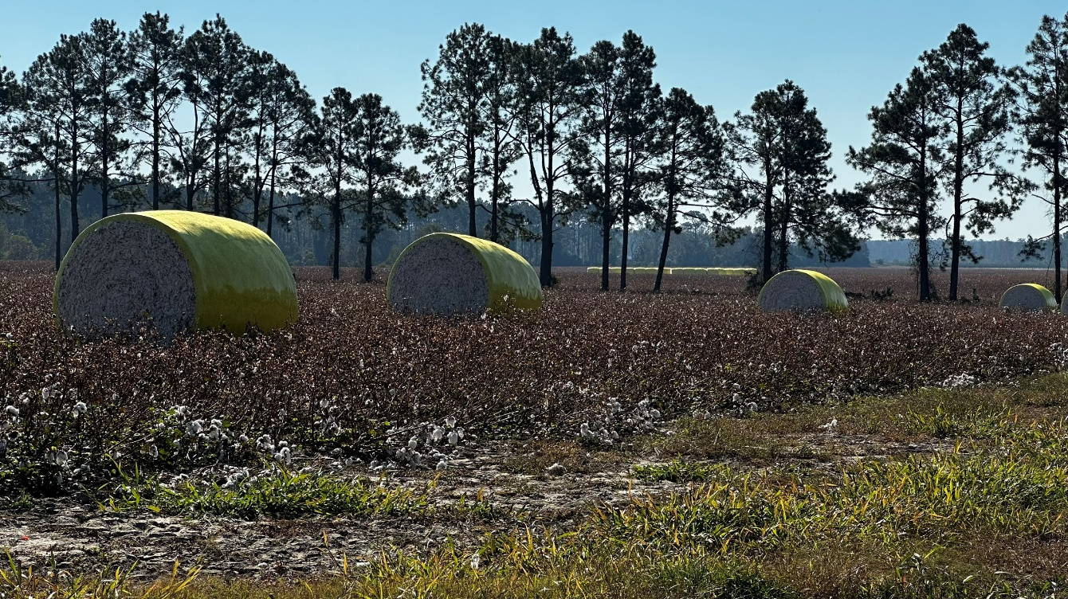

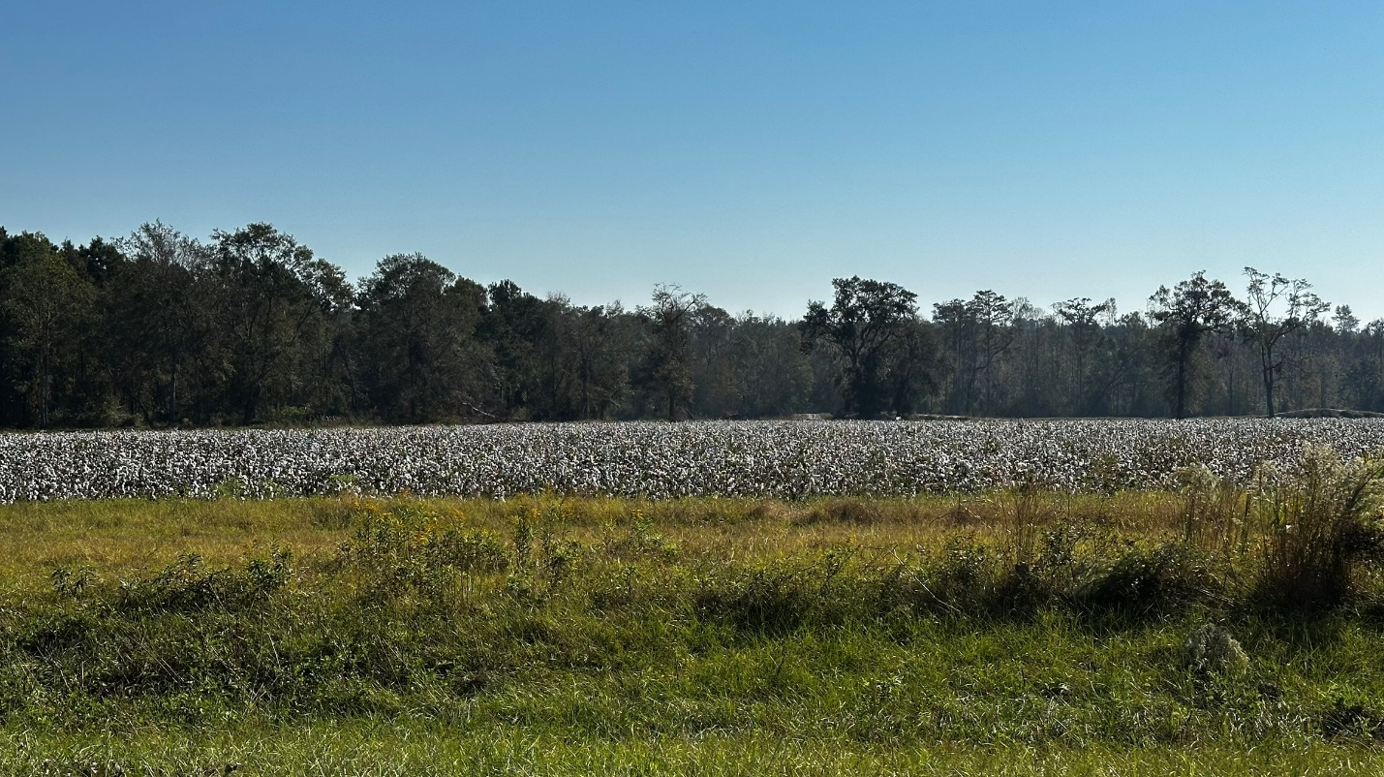

PREDOMINANT LAND USES:

Agricultural farm operations and related activities, natural resource conservation, groundwater recharge areas, and low-density residential development accessory to agricultural or farm operations of varying sizes.

DEVELOPMENT STRATEGY:

Preserve the rural/agricultural character of these areas by maintaining very low-density residential development primarily accessory to farm operations and large lot sizes. The use of conservation easements to protect environmentally sensitive areas should be encouraged. Roadways in these areas should be widened only when required to meet public safety standards.

PERMITTED ZONING DISTRICTS:

Agricultural

QUALITY COMMUNITY OBJECTIVES:

- Economic Prosperity
- Resource Management
- Sense of Place

IMPLEMENTATION MEASURES:

  - Berrien County should develop a comprehensive inventory of natural resources within the County to ensure their protection and continued preservation (Policy 1a.2).

  - Promote and encourage sustainable and innovative agri-business opportunities (Policy 2.10).

  - Coordinate with Moody Air Force Base via the JLUS study to ensure that any flight impacts to cultural and natural resources within Berrien County are mitigated (Policy 4.2).

Agriculture / Residential
(Cities of Alapaha, Enigma, and Ray City)

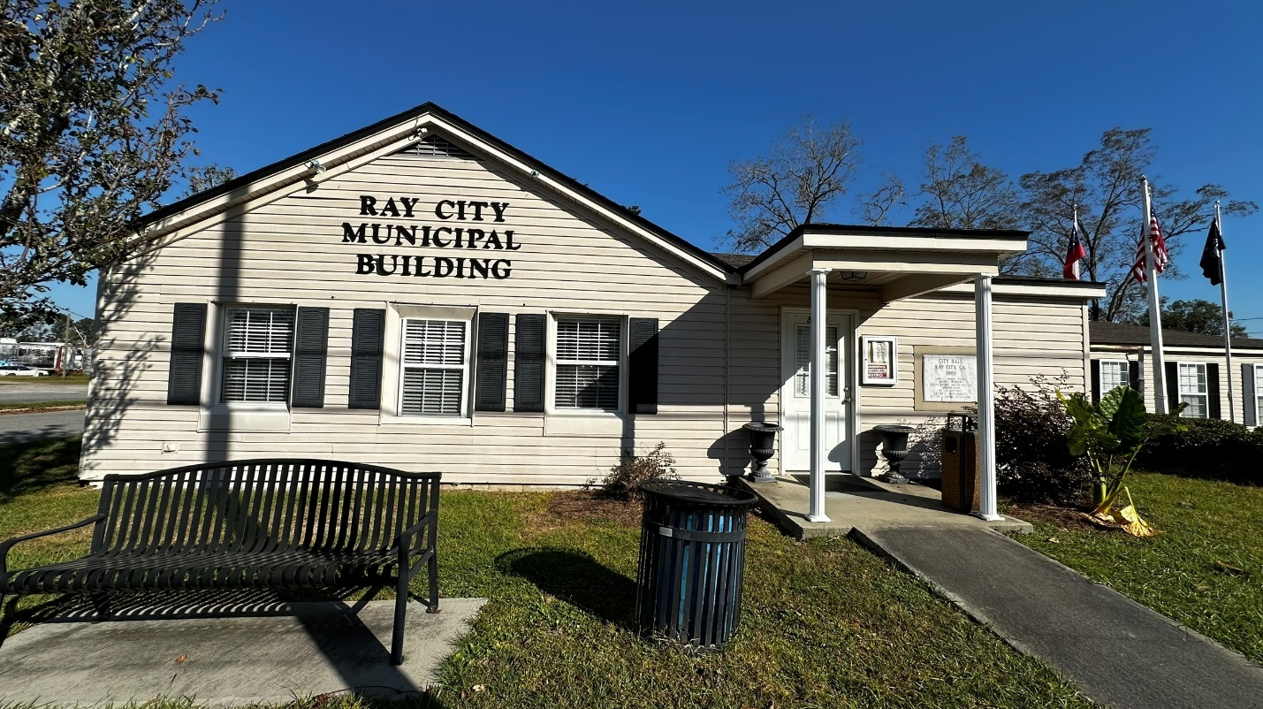
Ray City - City Hall

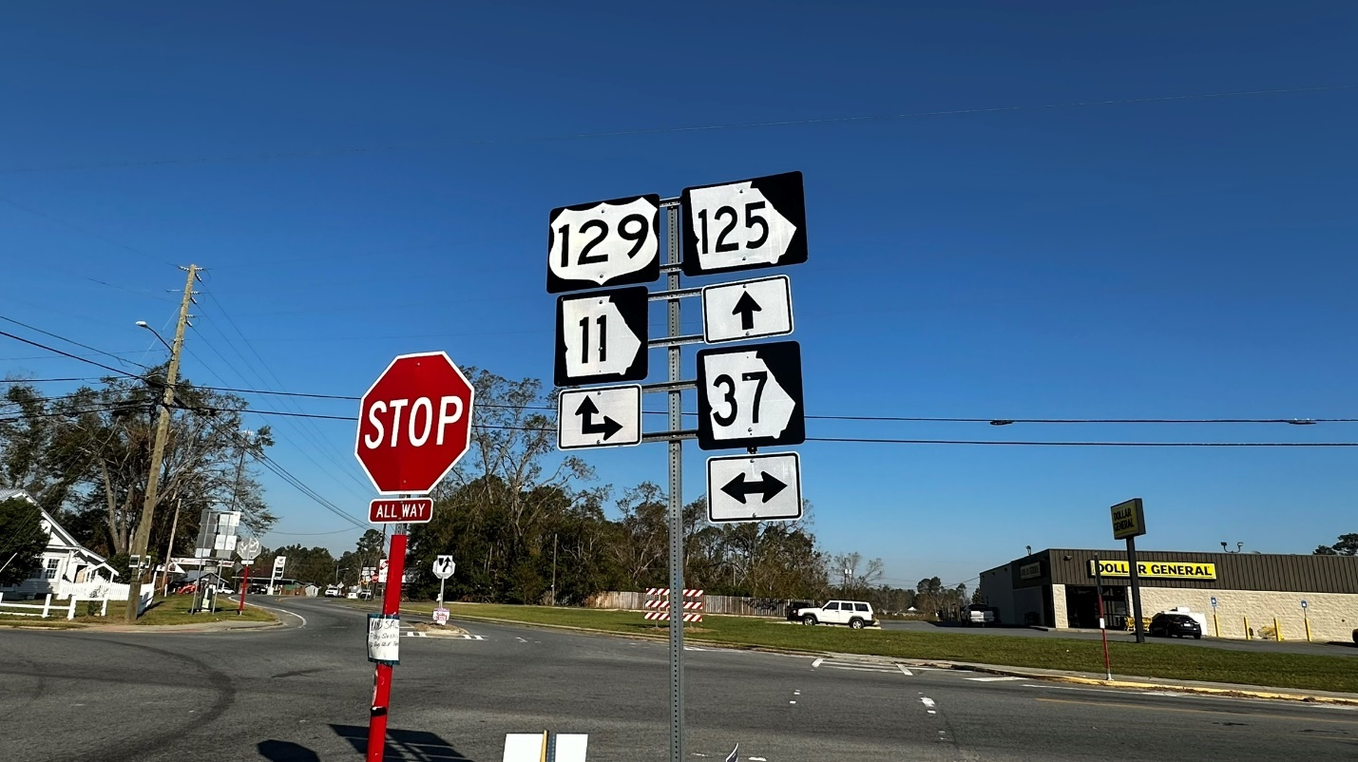
Intersection of SR Hwy 125 and Hwy 37 in Ray City

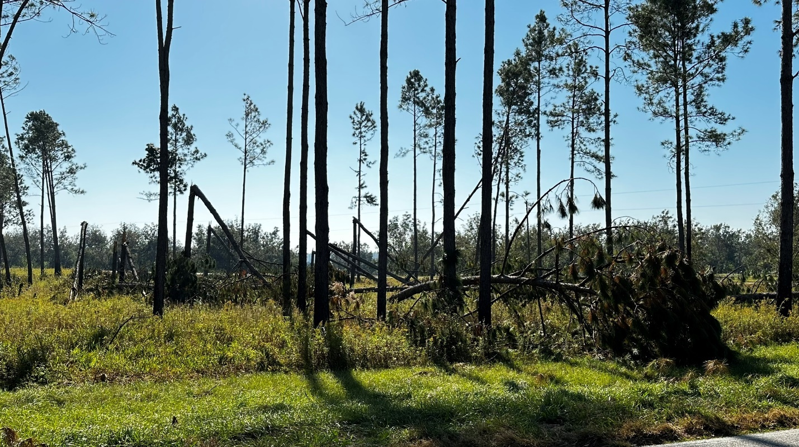
Rural Berrien County

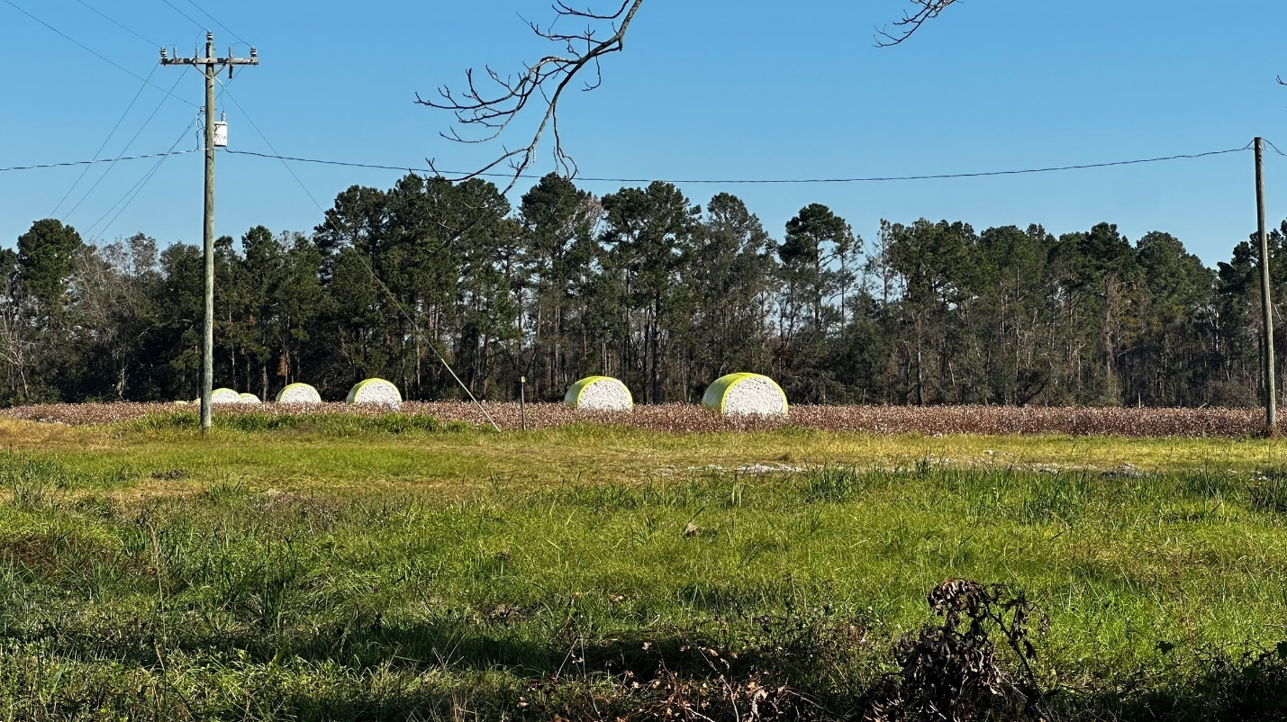
Rural Berrien County

DESCRIPTION

These are agricultural areas within the Cities of Alapaha, Enigma, and Ray City, closer to the periphery of the city and outside the downtown area. These areas are a combination of smaller farms, larger residential lots, and undeveloped areas such as forests and swamps.

PREDOMINANT LAND USES:

Smaller-scale agricultural operations, natural resource conservation, groundwater recharge areas, and low-density residential development.

DEVELOPMENT STRATEGY:

Since these areas are within incorporated cities, it is expected that they will eventually be built out with more residential development as population grows. However, rural character should be preserved.

PERMITTED ZONING DISTRICTS:

Agricultural
Residential

QUALITY COMMUNITY OBJECTIVES:

- Economic Prosperity
- Resource Management
- Sense of Place

IMPLEMENTATION MEASURES:

        - Berrien County should develop a comprehensive inventory of natural resources within the County to ensure their protection and continued preservation (Policy 1a.2).
        - Support and enhance Code Enforcement departments and personnel throughout the County (Policy 3.6).
        - Improve maintenance standards for mobile home park developments (Policy 3.7).
        - Develop a county-wide zoning ordinance (Policy 4.6).

Airport / Industrial
(City of Nashville)

DESCRIPTION

This character area consists of the Berrien County Airport and adjacent industrial park, as well as other nearby industrial areas.
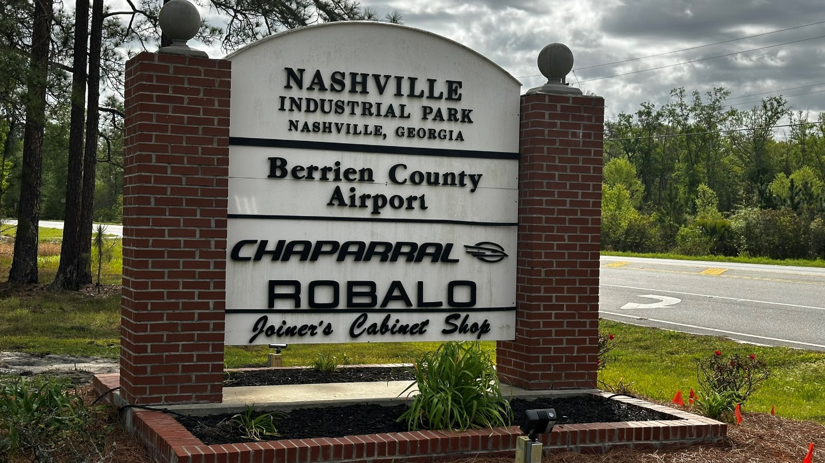
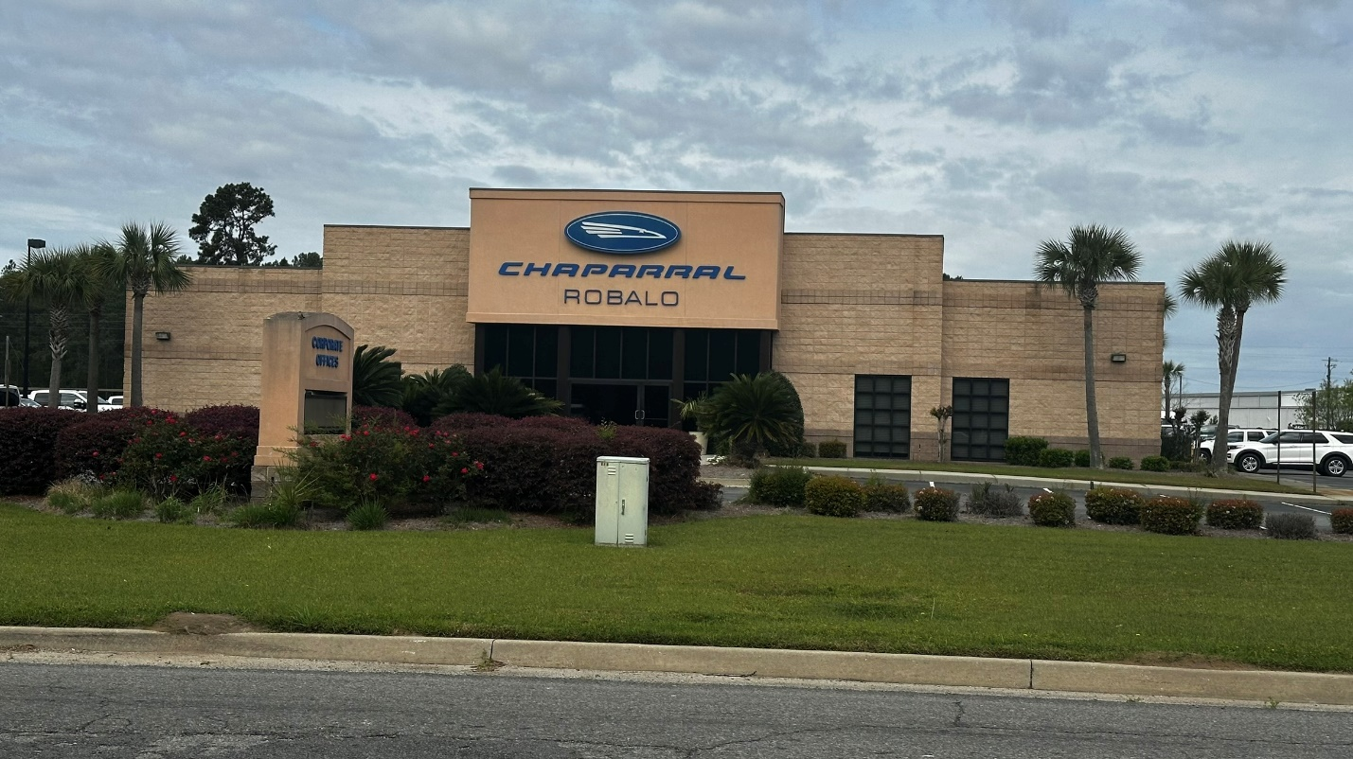

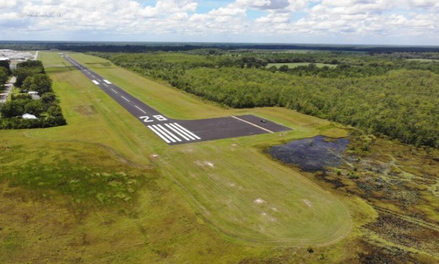

PREDOMINANT LAND USE:

Manufacturing, processing, warehouses, logistics, and airport.

DEVELOPMENT STRATEGY:

Provide an environment suitable for light and heavy manufacturing, wholesale, and warehousing activities that may impose undesirable noise, vibration, odor, dust, or other offensive effects on the surrounding area. Provide adequate buffering and distance from residential uses and other incompatible uses, but ensure that adequate access is provided for employees, freight, emergency vehicles, and all other transportation needs.

PERMITTED ZONING DISTRICTS:

Wholesale/Light Industrial
HI – Heavy Industrial

QUALITY COMMUNITY OBJECTIVES:

1) Economic Prosperity

IMPLEMENTATION MEASURES:

- Establish an ongoing Committee with representation from the County and Moody Air Force Base to identify and foster mutually beneficial growth and development projects and programs within the area (Policy 2.3).

- Develop a coordinated county-wide business presence plus increase broadband coverage to increase inventory (Policy 2.5).

- Develop a county-wide online business registry (Policy 2.6).

  - Coordinate with Moody Air Force Base via the JLUS study to ensure that any flight impacts to cultural and natural resources within Berrien County are mitigated (Policy 4.2).

Commercial
(Berrien County and Downtown of Alapaha and Nashville)

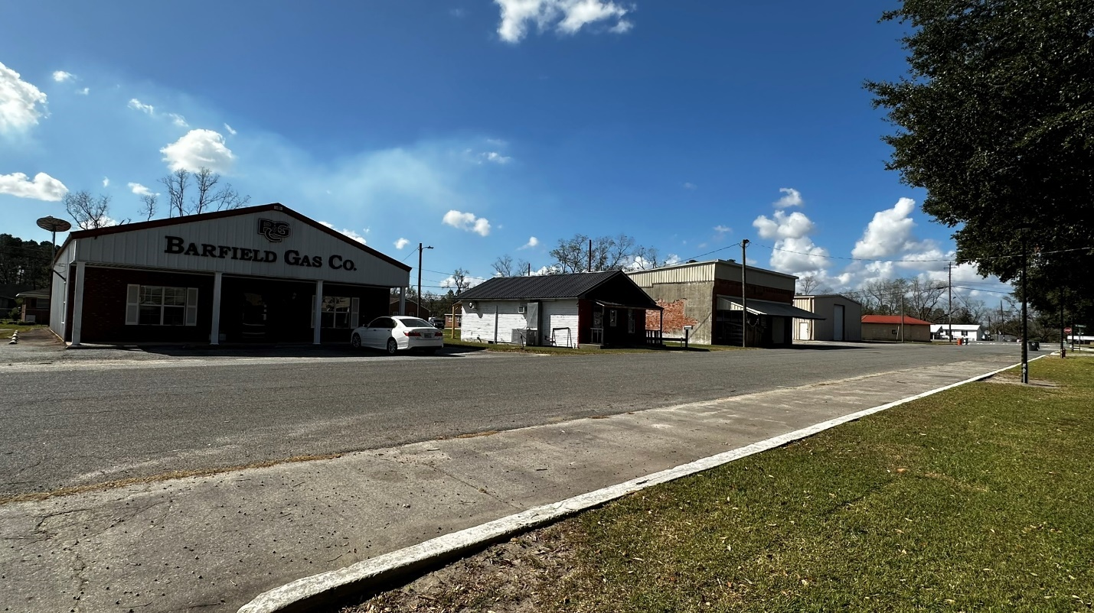

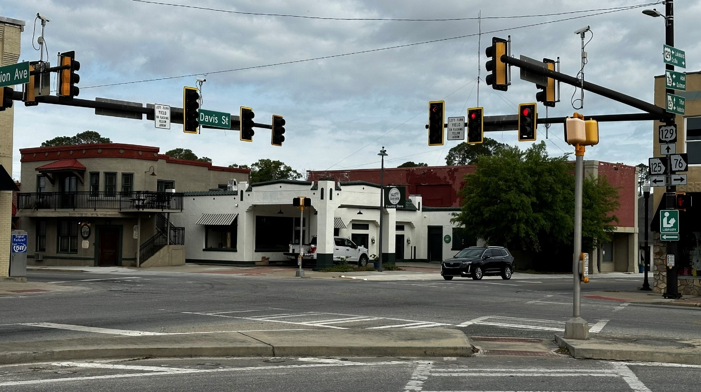

DESCRIPTION

This character area consists of commercial areas that are outside of the downtown areas of the cities. This area includes both higher-intensity commercial areas on the periphery of the cities, and commercial hubs in rural areas. These areas generally contain retail and service uses that can function independently of adjoining development.

PREDOMINANT LAND USE:

The primary land uses in this area are higher-intensity commercial. Some areas are still agricultural or undeveloped.

DEVELOPMENT STRATEGY:

Encourage clustered commercial development in rural areas. In the more urban commercial areas of Nashville, encourage a walkable environment. Encourage businesses that provide employment and amenities to residents of the community.

PERMITTED ZONING DISTRICTS:

Commercial
General Business

QUALITY COMMUNITY OBJECTIVES:

- Economic Prosperity
- Resource Management

IMPLEMENTATION MEASURES:

- Develop a coordinated county-wide business presence plus increase broadband coverage to increase inventory (Policy 2.5).

- Develop a county-wide online business registry (Policy 2.6).

- Promote and support existing and expanding local businesses and industries (Policy 2.9).

Downtown Core (Enigma)
(City of Enigma)

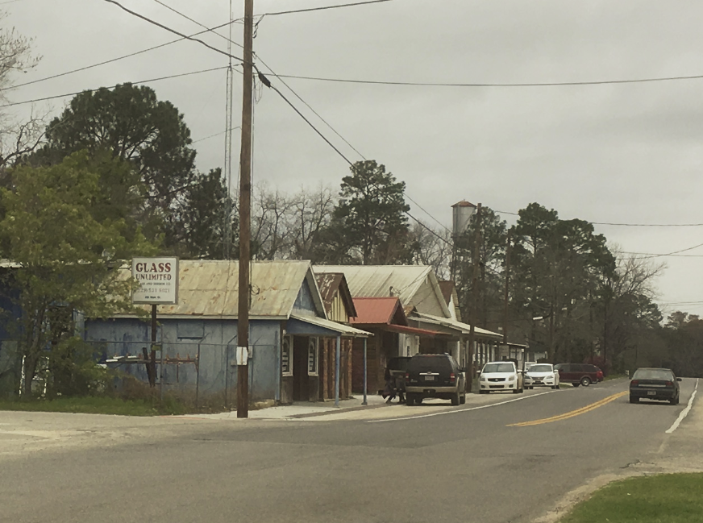

DESCRIPTION

This is the historic downtown area of Enigma.

PREDOMINANT LAND USES:

Historic commercial core with adjacent residential, institutional, and agricultural uses.

DEVELOPMENT STRATEGY:

Preserve the historic character of the Main Street area and the rural character of the community as a whole. Encourage businesses to locate in the Main Street area. Encourage infill development and adaptive reuse.

PERMITTED ZONING DISTRICTS:

Commercial
Residential (single-family and multi-family)
Residential Professional
Mixed Use
Public/Institutional

QUALITY COMMUNITY OBJECTIVES:

- Sense of Place
- Efficient Land Use
- Economic Prosperity

IMPLEMENTATION MEASURES:

- Research ways to promote historical tourism within the County, including historical designations, tours, downtown events, and historical marketing efforts (Policy 1b.2).
- If not consolidating ordinances with the county, the City of Enigma needs to adopt a zoning ordinance (Policy 4.9).
- Develop a county-wide online business registry (Policy 2.6).
- Promote and support existing and expanding local businesses and industries (Policy 2.9).

Downtown Core (Ray City)
(City of Ray City)

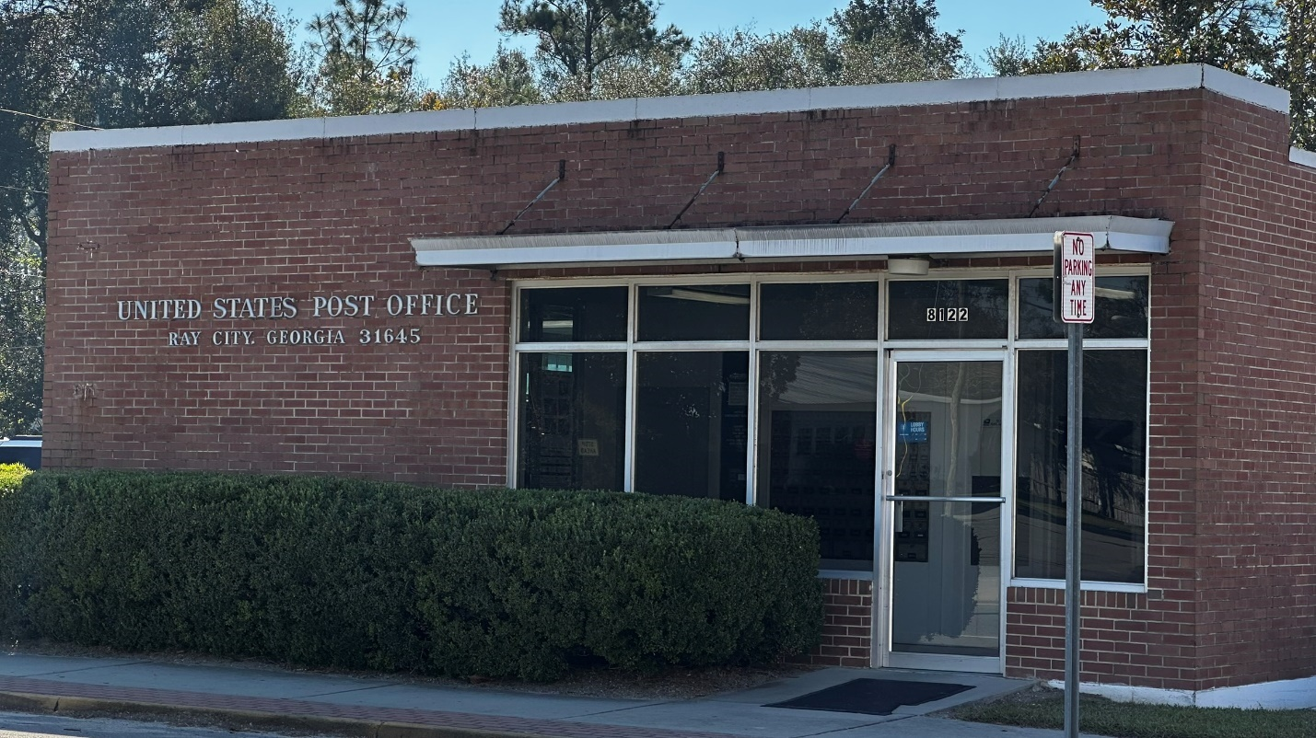

DESCRIPTION

This is the historic downtown area of Ray City.

PREDOMINANT LAND USES:

Historic commercial core with adjacent residential and institutional uses.

DEVELOPMENT STRATEGY:

Preserve the historic character of the Main Street area and adjacent residential areas. Encourage businesses to locate in the Main Street area. Encourage infill development and adaptive reuse.

PERMITTED ZONING DISTRICTS:

Commercial
Residential (single-family and multi-family)
Residential Professional
Mixed Use
Public/Institutional

QUALITY COMMUNITY OBJECTIVES:

- Sense of Place
- Efficient Land Use
- Economic Prosperity

IMPLEMENTATION MEASURES:

- Research ways to promote historical tourism within the County, including historical designations, tours, downtown events, and historical marketing efforts (Policy 1b.2).
- Develop a county-wide online business registry (Policy 2.6).
- Promote and support existing and expanding local businesses and industries (Policy 2.9).

Downtown Historic District (Nashville)
(City of Nashville)

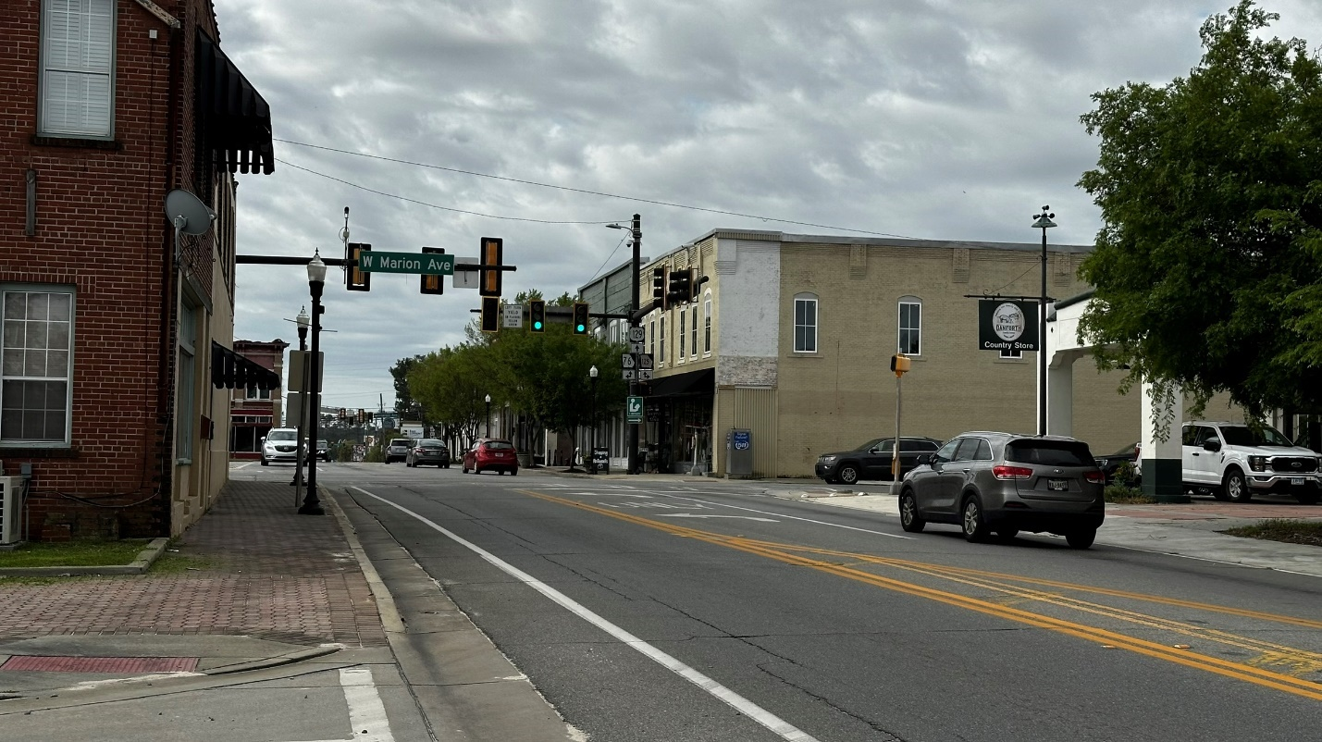

DESCRIPTION

This is the historic commercial core of the City of Nashville, including the historic ourthouse square and downtown businesses, as well as adjacent institutional and residential areas.

PREDOMINANT LAND USES:

Historic commercial core with adjacent historic residential and institutional uses.

DEVELOPMENT STRATEGY:

Preserve the historic character of the downtown area and historic residential areas. Encourage businesses to locate in and near the downtown area. Encourage infill development and adaptive reuse. Continue to develop a walkable environment.

PERMITTED ZONING DISTRICTS:

Commercial
Residential (single-family and multi-family)
Residential Professional
Mixed Use
Public/Institutional

QUALITY COMMUNITY OBJECTIVES:

- Sense of Place
- Efficient Land Use
- Economic Prosperity

IMPLEMENTATION MEASURES:

- Research ways to promote historical tourism within the County, including historical designations, tours, downtown events, and historical marketing efforts (Policy 1b.2).
- Support the Main Street Program in its efforts to bring visitors into Berrien County (Policy 1b.3).
- Develop a county-wide online business registry (Policy 2.6).
- Promote and support existing and expanding local businesses and industries (Policy 2.9).

Forestry
(Unincorporated Berrien County)

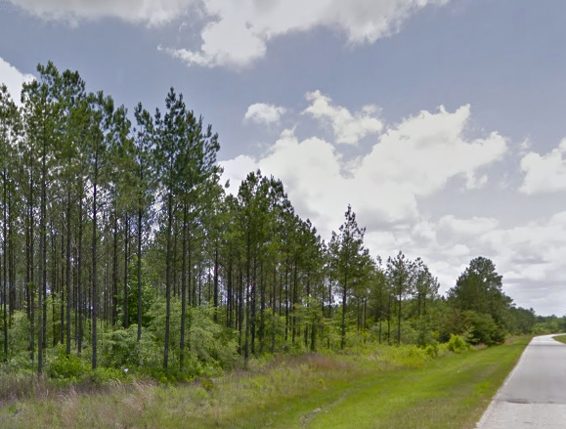

DESCRIPTION

These are areas of unincorporated Berrien County used for the planting, managing, and harvesting of trees for commercial use.

PREDOMINANT LAND USES:

Forestry

DEVELOPMENT STRATEGY:

Encourage sound forest management practices and sustainable harvesting of trees. Implement traffic safety measures for transportation of forest products in order to reduce the risk of crashes involving log trucks.

PERMITTED ZONING DISTRICTS:

Agriculture/forestry

QUALITY COMMUNITY OBJECTIVES:

- Economic Prosperity
- Resource Management
- Sense of Place

IMPLEMENTATION MEASURES:

  - Berrien County should develop a comprehensive inventory of natural resources within the County to ensure their protection and continued preservation (Policy 1a.2).

  - Promote and encourage sustainable and innovative agri-business opportunities (Policy 2.10).

  - Coordinate with Moody Air Force Base via the JLUS study to ensure that any flight impacts to cultural and natural resources within Berrien County are mitigated (Policy 4.2).

Gateway Corridor
(City of Nashville)

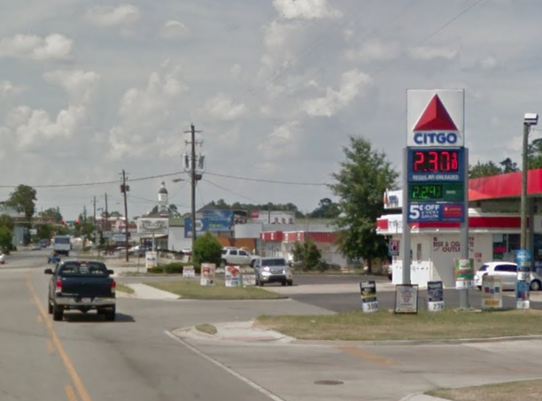

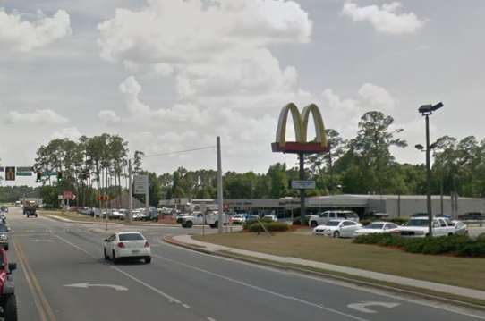

DESCRIPTION
This commercial corridor forms the gateway area into the City of Nashville as one enters from the south on US-129. This area represents the first impression of the City of Nashville for many visitors as they approach the downtown historic district. As such, this area is highly significant for tourism and the local economy.

PREDOMINANT LAND USES:

Commercial

DEVELOPMENT STRATEGY:

Improve aesthetic appeal to improve impressions made to visitors to the community. Continue to build out sidewalks and create a walkable environment, since this gateway area is adjacent to many residential neighborhoods and to the walkable downtown area. Manage traffic flows and limit curb cuts in order to improve safety and visual appeal. Encourage shared parking and access between parking lots in order to facilitate traffic flows. Encourage street trees and landscaping in order to increase the visual appeal of the area. Coordinate with GDOT for improvements to streetscaping.

PERMITTED ZONING DISTRICTS:

Commercial

QUALITY COMMUNITY OBJECTIVES:

- Sense of Place
- Efficient Land Use
- Economic Prosperity

IMPLEMENTATION MEASURES:

- The City of Nashville should consider the development and adoption of a historic overlay district, which should be coordinated with the Nashville Historic Area ARSA (Policy 1b.4).

- Promote and support existing and expanding local businesses and industries (Policy 2.9).

- Implement stormwater best management practices for all new development within the City of Nashville (Policy 4.7).

Historic Main Street Area (Alapaha)
(City of Alapaha)

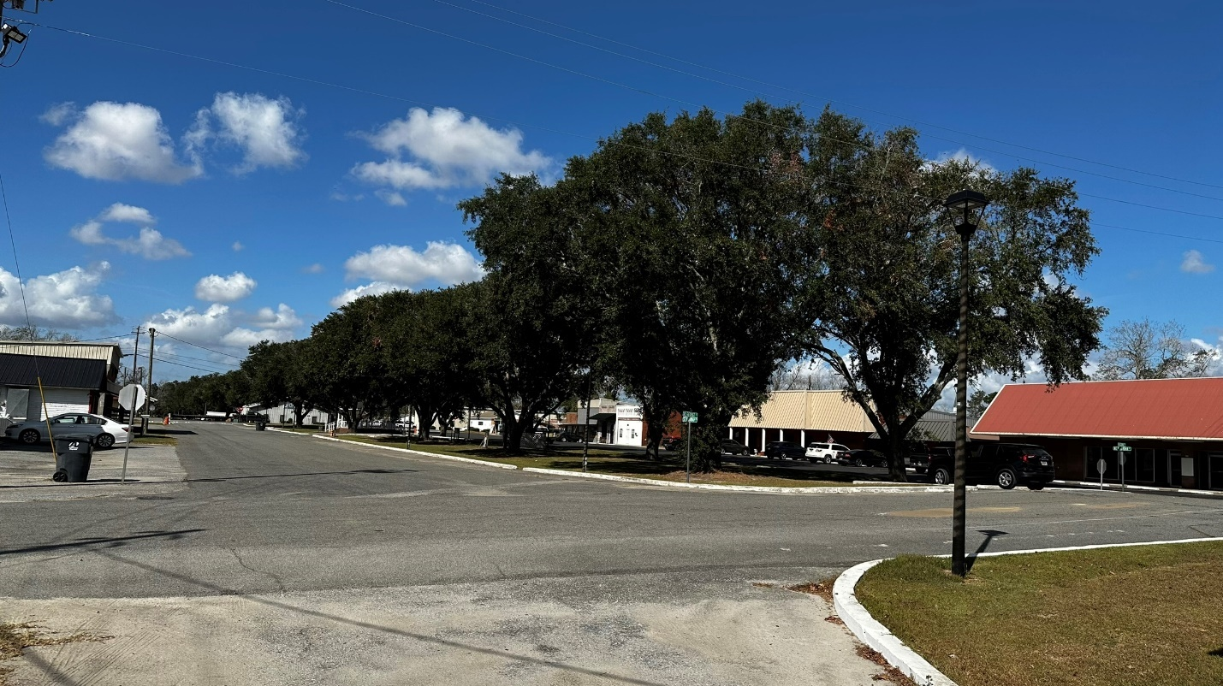

DESCRIPTION

This is the historic downtown area of Alapaha.

PREDOMINANT LAND USES:

Historic commercial core with adjacent residential and institutional uses.

DEVELOPMENT STRATEGY:

Preserve the historic character of the Main Street area and adjacent residential uses. Encourage businesses to locate in the Main Street area. Encourage infill development and adaptive reuse.

PERMITTED ZONING DISTRICTS:

Commercial
Residential (single-family and multi-family)
Residential Professional
Mixed Use
Public/Institutional

QUALITY COMMUNITY OBJECTIVES:

- Sense of Place
- Efficient Land Use
- Economic Prosperity

IMPLEMENTATION MEASURES:

- Research ways to promote historical tourism within the County, including historical designations, tours, downtown events, and historical marketing efforts (Policy 1b.2).
- Develop a county-wide online business registry (Policy 2.6).
- Promote and support existing and expanding local businesses and industries (Policy 2.9).

Public / Institutional
(Berrien County and Cities of Alapaha, Nashville, and Ray City)
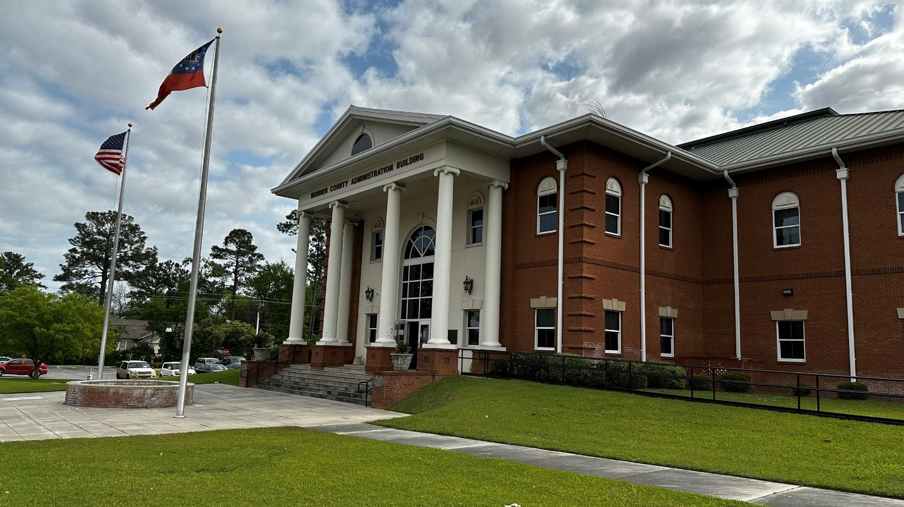
DESCRIPTION

This category includes specific state, federal or local government uses, and institutional land uses. Government uses include government offices, government building complexes, police and fire stations, libraries, prisons, and post offices. Examples of institutional land use include colleges, schools, churches, parks and recreational facilities, cemeteries, and hospitals.

PREDOMINANT LAND USE:

Institutional/government buildings and public areas.

DEVELOPMENT STRATEGY:

Preserve, restore, and reuse historic buildings. Implement a balance of transportation options and design. Encourage development of essential facilities in locations where they can be conveniently accessed. Encourage development of new public/institutional uses at a scale that is compatible with surrounding uses.

PERMITTED ZONING DISTRICTS:

Public/Institutional

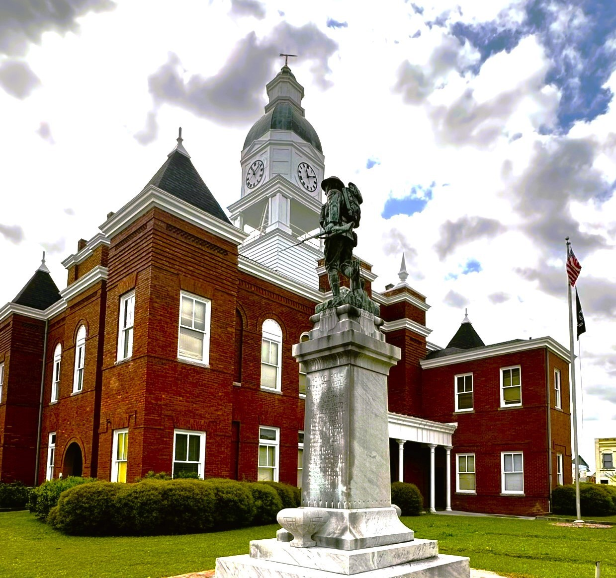

QUALITY COMMUNITY OBJECTIVES:
1) Local Preparedness
2) Economic Prosperity
3) Efficient Land Use
4) Community Health
5) Transportation Options

IMPLEMENTATION MEASURES:

- Develop a county-wide zoning ordinance (Policy 4.6).

Residential
(Berrien County and Cities of Alapaha, Enigma, Nashville, and Ray City)

DESCRIPTION

Development in this character area is predominantly residential, ranging from single-family to multi-family densities. Uses also allowed within this district include public and private schools, churches, and other uses as permitted within the zoning districts within this character area.
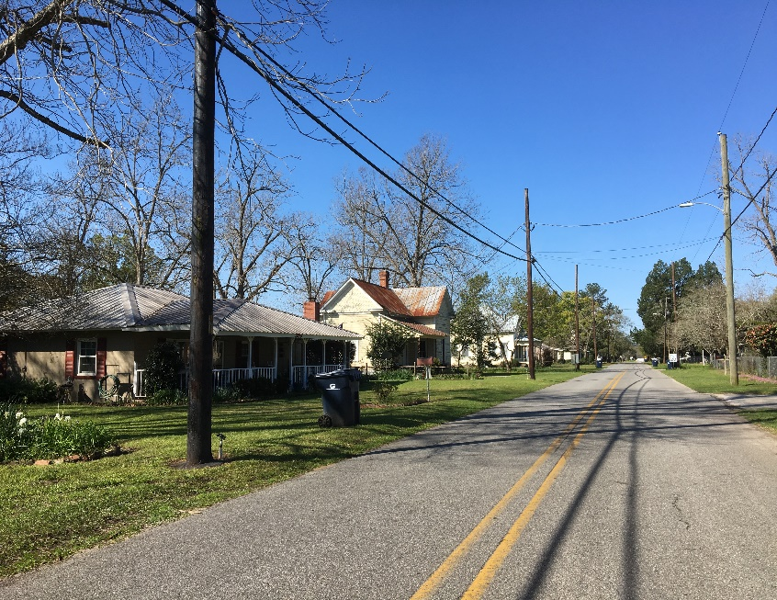

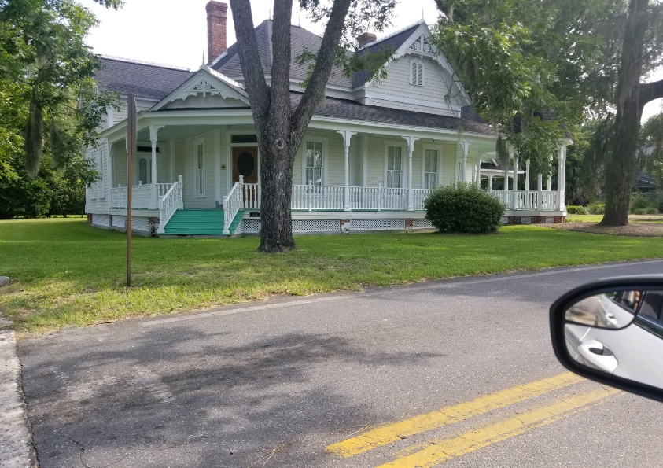
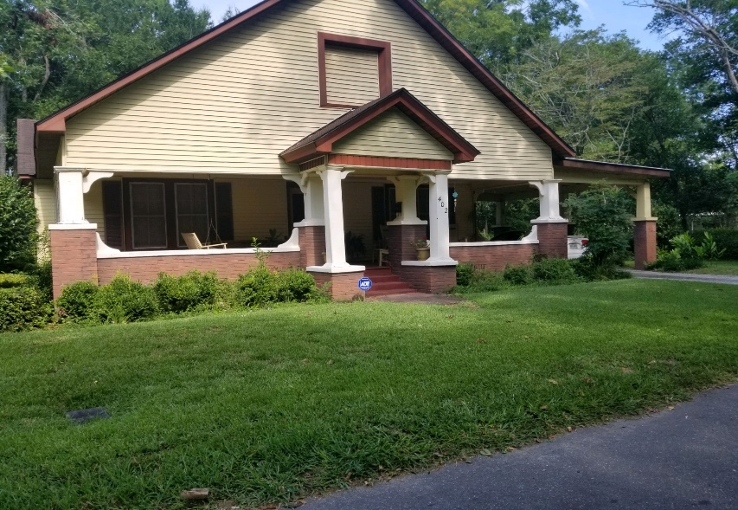

DEVELOPMENT STRATEGY:

The focus should be on reinforcing stability by encouraging more homeownership and maintenance or upgrade of existing properties. Vacant properties in the neighborhood offer an opportunity for infill development of new, architecturally compatible housing. A walkable and environment should also be provided, with sidewalks and bike paths where appropriate.

PREDOMINANT LAND USE:

The predominant land use in this area is residential. Compatible uses that provide amenities to residential neighborhoods should also be encouraged, such as neighborhood-scale businesses and offices, parks, places of worship, and schools.

PERMITTED ZONING DISTRICTS:

Single-family Residential
Multi-family Residential
Neighborhood Commercial
Residential Professional
Public/Institutional

QUALITY COMMUNITY OBJECTIVES:

- Economic Prosperity
- Efficient Land Use
- Resource Management
- Sense of Place
- Housing Options

IMPLEMENTATION MEASURES:

        - Support and enhance Code Enforcement departments and personnel throughout the County (Policy 3.6).
        - Improve maintenance standards for mobile home park developments (Policy 3.7).
        - Develop a county-wide zoning ordinance (Policy 4.6).
        - Research the Community Development Block Grant (CDBG) funding and Georgia Initiative Community Housing (GICH) opportunities that can help develop suitable low-income housing (Policy 3.1).
        - Identify affordable housing properties and create a listing that will be available to the public (Policy 3.2).
        - Identify areas where in-fill housing can be accommodated within the County, and coordinate with the property owners to coordinate public and private funds and efforts (Policy 3.3).

Rural Highway
(Berrien County and City of Enigma)

DESCRIPTION

The purpose of this character area is to provide for and protect areas that mix compatible agricultural, commercial, and light industrial uses along major highways in the community. These areas are mostly located along US-82, US-129, and SR-125. Some large-lot residential uses also exist in these areas.
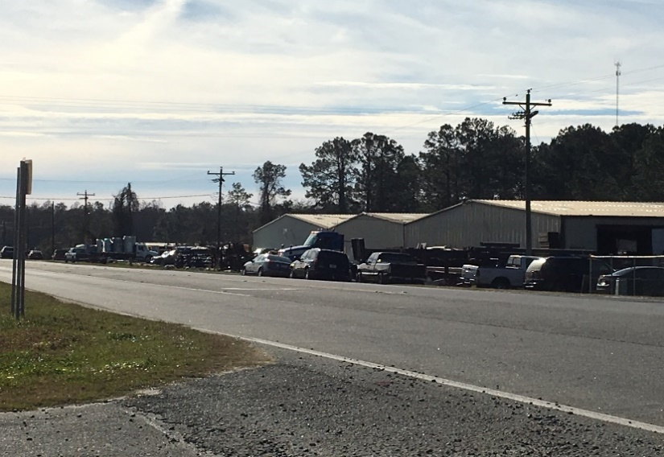

DEVELOPMENT STRATEGY:

Preserve the rural character of these areas while encouraging the development of businesses that provide employment and amenities to the community as a whole. Encourage the development of services that are of use to the residents who live near these rural corridors, such as grocery stores. Enforce septic tank regulations to preserve the area’s water quality.

PERMITTED ZONING DISTRICTS:

Agricultural
Commercial
Light Industrial
Public/Institutional
Residential

QUALITY COMMUNITY OBJECTIVES:

- Sense of Place
- Efficient Land Use
- Housing Options

IMPLEMENTATION MEASURES:

- Develop a county-wide online business registry (Policy 2.6).
- Promote and support existing and expanding local businesses and industries (Policy 2.9).

